RESUME
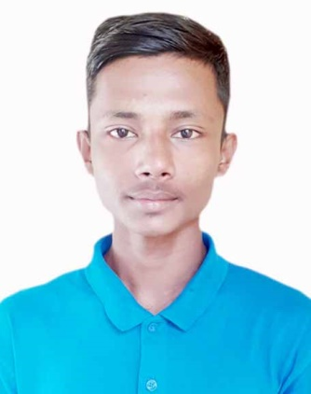

Photo
OF
SAKIR MIAH
Mobile: 01754-395215
Email: ariyanshakil04@gmail.com

Career Objective

I am willing to work in a challenging environment and rewarding position, where dignity of work provides job satisfaction and the place of work provides Potential Avenue for learning and growing and to achieve top level in the hierarchy of the organization.

Educational Qualification

HSC Examination

            - Institution : Burunga Iqbal Ahmed High School And
College.
            - Group : Humanities
            - Year of Passing : 2019
            - Board : Sylhet
- Secondary School Certificate (SSC)

            - Institution : Burunga Iqbal Ahmed High School And
College.
            - Group : Humanities
            - GPA : 2.06 (Out of 5.00)
Year of Passing : 2019
            - Board : Sylhet
- JDC Examination
            - Institution : Burunga Iqbal Ahmed High School And
College.
            - GPA : 3.00 (Out of 5.00)
Year of Passing : 2015
            - Board : Sylhet

Computer Skill:

- Microsoft Word.
- Microsoft Excel.
- Microsoft Power Point.
- Internet & E-mail (BCC).

Experience:.

- Niz Burunga Post E-center (3 Year).

Personal Information
- Name : Sakir Miah
- Father’s Name : Sofik Miah
- Mother’s Name : Sajna Begum
- Present Address : Vill: Mokbel Pur, P.O: Suna pur,
P.S: Balagonj, Sylhet.
- Permanent Address : Vill: Mokbel Pur, P.O: Suna pur,
P.S: Balagonj, Sylhet.
- Date of Birth : 03/08/2001
- Marital Status : Unmarried
- Religion : Islam
- Nationality : Bangladeshi (By birth)
- Gender : Male
- Mobile Number : 01754-395215
About me:

I have tried to be an honest man. If get good and honorable job heartily I will try my best. I am very quick learned and able to develop new areas of expertise. I am highly motivated, organized and able to work under pressure as team leader.

Declaration:
I Declare that all the information includes here are true to my knowledge. It required and where applicable, this document can be supported by appropriate authentic certificates.
Reference

Abdul Qaium Chowdhury
CID Inspector
01711-485548

Date: …………………………
(Sakir Miah)

