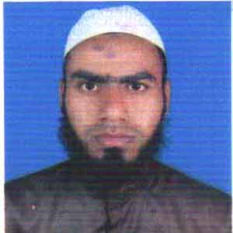
CURRICULUM VITAE
OF
OBAIDUL HAQUE
Mailing Address:
ObaidulHaque
Vill: khaduli, Post; pirhati,
Upazila: Dhunat,Dist: Bogra.Contact Address:
Mobile No:01518420126,01813066862
E-mail: obaidulkhaduli1994@gmail.com

Academic Qualification

M.B.A ( Master of Business Administration):

University : National university
Institution : Anondo Mohon College.Mymensing.
Concentration/major : Management
Examination year : 2017
Result : C.GPA 2.41(Out of 4)

B.B.A (Bachlor of Business Administration):

University : National university
Institution : Syed Ahmed Collage,Gobtoli, Bogra
Concentration/major : Management
Examination year : 2015
Result : C.GPA 2.75(Out of 4)

H.S.C (HIGHER SCONDARY CERTIFICATE):

Board : Rajshahi
Institution : Govt. shah sultanCollage,Gobtoli, Bogra
Concentration/major : Business Studies
Examination year : 2011
Result : GPA 3.90(Out of 5)

S.S.C (SCONDARY SCHOOL CERTIFICATE):

Board : Rajshahi
Institution : M.P.S.T high school, Dhunat, Bogra
concentration/major : Business Studies
examination year : 2009
Result : GPA 4.00(Out of 5)

Computer skills:
- Well conversant with popular packages like Ms-word, Ms- Excel.
- Seba NGO, SATU NGO 3 Years Experience

Strengths:
- Ability to work hard
- Excellent interpersonal communication skills
- Quality and prompt decision making ability
- Ability to build group and control

Personal Information:

- Name : Obaidulhaque

- Father`s Name :AltafHossain

- Mother`Name :Sshajadakhatun

- Date of birth :27-01-1994

- Nationality : Bangladeshi

- Religion : Islam

- Marital status : Unmarried

- Sex : Male

- hight : 5’8’’

- weight : 65kg

- Nid: 19941012785000388

- Permanent Address :Vill : khaduli , P.O : Pirhati
P.S :Dhunat , Dist : Bogra
Bangladesh

- Present Address :Vill : khaduli , P.O : Pirhati
P.S :Dhunat , Dist : Bogra
Bangladesh

declaration:

I do hereby declare that the above information ts true and correct to the best of my khowledge

signature

(Obaidulhaque)

