
Curriculum vitae
Of
Md.Asadujjman Tuhin
Cell: 01717142823
Email: asadujjmantuhin.eee@gmail.com
Present address:
Thana/Post: Ranisankail. District: Thakurgaon. Division: Rangpur.
Permanent address:
Thana/Post: Ranisankail. District: Thakurgaon. Division: Rangpur.
Self-Assessment:
A self-driven attitude, willingness to learn and a strong presence of mind.
Optimistic confident and benevolent. Energetic, devoted, sincere and hardworking.
Academic Qualification :
Name of exam | Group/ sub | Year of passing | Institute.  University | Results: GPA
SSC | Automotive | 2006 | Bangladesh Technical  Education Board Dhaka. | 3.41
HSC | Computer | 2009 | Bangladesh Technical  Education Board Dhaka. | 3.78
BSC (Hon’s) | Electrical And Electronic Engineering. | 2014 | Atish Dipankar University of Science and Technology. (ADUST) | 3.20
MSC(Masters) | Electrical And Electronic Engineering. | 2019 | BRAC University. | In Progress
Training Summary:
Training Title | Topic | Institute | Location | Year | Duration
Farming | Farming Cattle. Farming Chicken. | Ranisankail  Upozela jubo | Ranisankail. | 2005 | 15 Days
Computer | Ms word, Excel, Access, Power Point, | Bangladesh  Computer  Education. | Rangpur | 2006 | 6 Month
Electrical House Wiring | Conduit Pipe,  Distribution Panel. | Thakurgaon Jubo (Gov) | Thakurgaon.  JogonathPur | 2007 | 6 Month
RAC: Freezer | A.C Basics.  Gas Change.  Gas Refill working. | Thakurgaon Jubo (Gov) | Thakurgaon.  JogonathPur | 2009 | 6 Month
Experience Employment History:
No | Company | Location | Responsibilities | Company Business | Designation | Duration
1. | KNB energy ltd. | Apt 1-A,Pragpur Road  P.O-Bheramara,  Dist: Kushtia. | Factory. | Electric. | Electrician. | June 1, 2015  December 30, 2017
2. | Labco Electronics Company Ltd. | House no: 134/a. 2nd block, Chittagong city. | IPS. UPS. AVS. DCPS | Electronics. | Asst. Engineer. | February 1, 2018  June 30, 2019.
3. | Rural Services Foundation (RSF) Rahimafrooz | 116, Maanco House. Arjatpara, Mohakhali. Dhaka. | Solar Home system. Solar AC, DC, Solar Strike light. | TR. KABITA. Solar And Battery. | Senior Officer- Operation | October 24, 2019  Continuing
Reference:
 | Reference : 1 | Reference : 2
Name : | Rezaul Karim Reza. | Wheduzzaman Dablu.
Organization : | LABCO company ltd. | Judge court.
Designation : | Officer. | Advocate in rajshahi judge court.
Address : | Office 143/c. road b. block I, Chattogram. | Kathalbariya more. kasiadanga. Rajshahi.
Mobile no : | 01717 427559 | 01711 302105
E-mail : | labcoele@yahoo.com
Relation : | Professional. | Relative.

Language Proficiency:
Confident Enough To Communicate Both In Bengali And English
Language | Listening | Reading | Writing | Speaking
Bengali | Excellent | Excellent | Very Good | Very Good
English | Excellent | Very Good | Very Good | Very Good
Personal Profile :

Name: Md. Asadujjman Tuhin

Father’s Name: Md. Alauddin

Mother’s Name: Farida Parvin

Date of Birth: 01.01.1989

Height: 5.5

Blood Group: B+

Weight: 65 kg

Religion: Islam

Marital Status: Single

Nationality: Bangladeshi

NID: 9428608774654

The information stated above is true
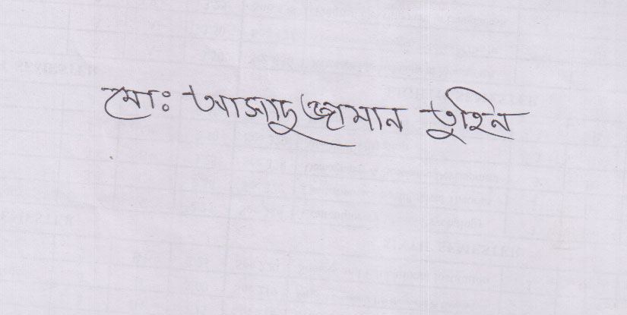
Signature

