CURRICULUM VITE
OF

ASHRAF UDDIN

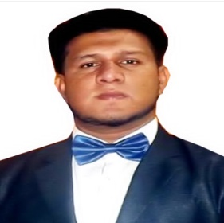

Choduwary Bazar,Sylhet-3108
Mobile No: 008801779033144
E-mail : suvon530602@gmail.com

PERSONAL INFORMATION :

Name : Ashraf Uddin
Father’s Nam : Faruk Uddin
Mother’s Name : Razia Sultana
Date of Birth : 24/06/1995
Village : Choduwary Bazar
Post officr : Choduwary Bazar- 3108
U.p : Golapgonj
Dist : Sylhet
Marital Status : Unmarried
Nationality : Bangladeshi (by birth)
Sex : Male
Religion : Islam
Mobail NO : 01779033144

ACADEMIC QUALIFICATION :

Diploma in Civil Engineering
Sylhet Polytechnic Institute Sylhet

Department : Civil
Grade : 3.27 ( Out of 4 )
Sessio : 2012-2013
Pass year : 2016

Secondary School Certificate (S.S.C.)

L.B. green flower High School Sylhet
GROUP : Science
G.P.A : 4.69 ( Out of 5 )
INDUSTRIAL TRAINING CERTIFICATE

Passing year : 2016

SPECIAL QUALIFICATION :

- FLEXIBLE ROAD, CULVART , REATAITING WALL,BRIDGE, RIGID PAVEMENT WORK.
- AUTO CAD PROFESSIONAL PROJECT WORK
- SUPERVISE THE PROJECT WORK
- PROFESSIONAL MS WORD & MS EXCEL WORK
- ESTIMATE OF CONSTRUCTION WORK

WORKING EXPERIENCE :

working I Have more then 4 year site work & professional Auto cad work experience .

At JAMIL IQBAL LTD sylhet.

LANGUAGE SKILL :
- BANGLA
- ENGLISH

Signature: CC\\\\

ASHRAF UDDIN

