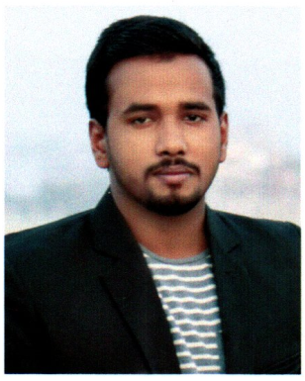
CURRICULUM-VITAE

OF

MD.SHARIF UDDIN
RESUME


Diploma in Textile Engineering
Mobile:+8801822224186

E-mail:sharifuddin0131@gmail.com

Career Objective:

I would like to build up my career of engineering sector through using my creatively, efficiency, proficiency and hard working so that my respective organization can achieve its goal in the circumstance of the global challenge and competition. I always prefer to take the challenges as opportunities for Textile Works.

Educational Qualification:

- Diploma in Engineering:

- Institute Name :BGIFT Institute of Science & Technology Gazipur.
- Board : Bangladesh Technical Education Board, Dhaka.
- Department : Textile Technology
- Duration of Course : Four Years.
- Passing Year : 2019
- CGPA : 3.49 (out of 4.00)

- Secondary School Certificate:

- School Name : Konabakhail Fazil Madrasah, Mymensingh
- Board : Dhaka
- Group : Science
- Year of Passing : 2015
- GPA : 4.39 (out of 5.00)

Personal Attributes:

- Individual & Team player.
- Hard Worker.
- Self-Motivated & Motivate to others.
- Strong desires for leading and honest life with dignity.
- Cross cultural communication skill.
- Faster learning attitude.

Industrial experience:

- Organization Name : Searock Apparels Ltd
- Address :Chaydana ,Gazipure.
- Duration : 1 Year
- DesignatDion : Trainee Marchandaizer

Computer Literacy:

- Package Program : Microsoft Word, Microsoft Excel, Microsoft PowerPoint.
Others : Internet Browsing, E-mail etc.

Language Proficiency:

Language | Speaking | Reading | Writing
Bangla | Excellent | Excellent | Excellent
English | Medium | Excellent | Excellent

Interested:
- Reading book,Listening Songs & Traveling.

Personal Details:

- Name : Md. Sharif Uddin
- Father’s Name : Md. Sulayman
- Mother’ Name : Sufia Khatun
- Date of Birth : 26/06/1999
- Sex : Male
- Marital Status : Single
- Height : 5 feet 4 inch
- Weight : 66 kg.
- Blood Group : B (+ve)
- Religion : Islam
- Place of Birth : Mymensingh
- National ID No. : 1504591361
- Nationality : Bangladeshi (By Birth)

Present & Permanent Address:

- Care of : Md. Sulayman
- Village : Nizbakhail
- Post Office : Shankivanga,
- Thana : Trishal
- District : Mymensingh.

Reference:

- Name: : Eng. M.A. Zinnah
- Mobile : +8801711-007108

Declaration:

‘I do hereby declare and certify that all the information stated above in these curriculum vitae is true and complete to the best of my knowledge and belief’.



Date:....................... Md. Sharif Uddin

