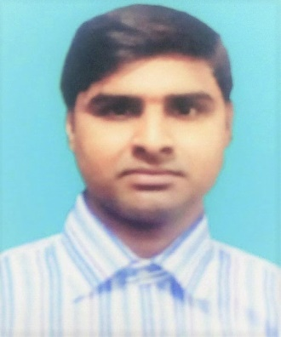
RESUME
OF
Md. SHAHIDUL ISLAM
Vill: Banuria, P.O: Bipinnagar,
P.S: Kaligonj, Dist: Jhenidah.
Mobile:01642655598
CAREER OBJECTIVE:
To work in a challenging environment where I would be able to interact and help enhance the performance of the company. I have the ability to learn quickly and can be assertive when my job demands it.
EDUCATION QUALIFICATION:
M.A (Master’s of Arts)
- Institute : Govt. M.M College, Jessore.
- University : National University.
- Subject : Bengali
- Passing Year : 2013
- Result : 2nd Division
B.A (Bechelor of Arts)
- Institute : Govt. M.M College, Jessore.
- University : National University.
- Subject : Bengali
- Passing Year : 2012
- Result : 2nd Division
H.S.C (Higher Secondary School Certificate)
- Institute : Shahid Nur Ali College.
- Board : Jessore
- Group : Humanities
- Passing Year : 2008
- Result : 4.40
S.S.C (Secondary School Certificate)
- Institute : B.C.S High School.
- Board : Jessore
- Group : Humanities
- Passing Year : 2006
- Result : 3.88
COMPUTER SKILL:
- Advance knowledge about Windows Operating System and Microsoft Office Suite (Word, Excel, Access & Power Point) Oracle, and Internet Browsing.
LANGUAGE SKILLS:
- Bangla, Fluency in speaking, reading writing and understanding.
- English, speaking, reading writing & Fluency in understanding.
PERSONAL INROMATION:
- Name : Md. Shahidul Islam
- Father’s Name : Md. Soleman Hossen
- Mother’s Name : Suraia Begum
- Date of birth : 05/01/1990
- Religion : Islam
- Nationality : Bangladeshi (By Birth)
- Marital Status : Married
- Gender : Male
- Permanent Address : Vill: Banuria, P.O: Bipinnagar,
P.S: Kaligonj, Dist: Jhenidah.
EXPERIENCE: New hope feed mill (bd) ltd. & zhongxin textile mill (bd) ltd 05/07/2015 to continue.total:-3.8 years.
CONFIDENCE:
I, am a smart, young, energetic, dynamic, good-looking, an outgoing pleasant personality and self- starter, strong inter- personal skill with an ability work at any place.

I, am undersigned, hereby declare that I will be responsible for any wrong information provided here.

Date: Signature

