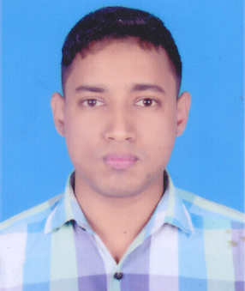
Curriculum Vitae

Md. Abdullah Al Masud
Vill: Jamgora, Post: Aliya Madrasha
Upazila: Ashulia, Dist: Dhaka
Cell No: 01756-724415

Career Objective:
I would like to work in any institution or organization where discipline and high-teach environment will ensure development and will make more skilful other sector. I went build my career, taking challenges and commitment to achieve results by working in any competent sector.

Educational Qualification:

Diploma in Textile Engineering
Institute : Bangladesh Institute of information Technology,
(BIIT), Bogra

Passing Year : 2017
Result : CGPA-3.34
Board : BTEB

Secondary School Certificate (S.S.C)
Institute : Jamtoil Dhopakandi Bhumukhi High School
Group : Science
Passing Year : 2012
Result : GPA-3.81
Board : Rajshahi

Personal Attributes:
- Good communication and Inter-Personal Skills.
- Capability of working to right time scale.
- Willingness to work under pressure.
- Confidence in performing duties independently.
- Flexibility to adapt to new atmosphere.

Language Proficiency:
Bengali : Mother Tongue.
English : Well versed in both written and spoken English.

Computer Skills:
Ms Word, Ms Excel, Ms Power Point & Internet Browsing.

Personal Information:
Name : Md. Abdullah Al Masud
Father’s Name : Md. Buzlur Rahman
Mother’s Name : Most: Hosneara Begum
Date of Birth : 30 January 1996
Religion : Islam
Marital Status : Unmarried.
Sex : Male
Nationality : Bangladeshi by birth
Height : 5 Feet 4 Inch
Weight : 60 Kg
Permanent Address : Vill: Haluakandi, Post: B. Jamtoil
Upazila: Kamarkhand, Dist: Sirajgonj

Declaration:
I am undersigned, thereby declare that I will be responsible for any wrong information provided here.


Signature
Date:.................................

Md. Abdullah Al Masud

