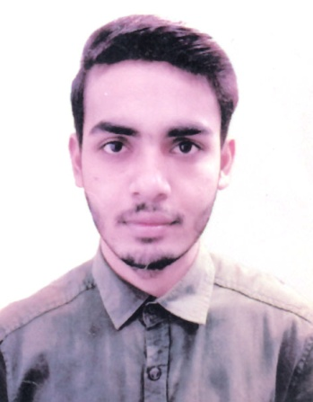
RESUME
OF
Md. Shahin Hossain

Mailing Address:
32/19 K, Tajmahal Road, Block-C,
Mohammadpur, Dhaka-1207
Mobile No: 01829426224
E-mail: shaheenhasan15@gmail.com

CAREER OBJECTIVE:

Build up a career challenging environment with excellent career development prospect, where hard work, strict discipline, good communication skill and creative problem solving are the comer stone of success.

EDUCATIONAL INFORMATION:

Bachelor of Social Science (B.S.S) Hon’s
Subject : Social Work
Institution : Govt. Barishal College
University : National University
Passing Year : 2018
Result : 2.88 (out of 4)

Higher Secondary Certificate (H.S.C)
Group : Business Studies
Institution : Ulania Muzaffor Khan Degree & College
Board : Barishal
Passing year : 2014
Result : 4.26 (out of 5)

Secondary School Certificate (S.S.C)
Group : Business Studies
Institution : Ulania Coronation High School
Board : Barishal
Passing year : 2012
Result : 3.94 (out of 5)

Job Experience:

- Worked as a Sales Execrative at Eva Super Shop for 3 Years.

COMPUTER LITERACY:

- Office Application : MS Word, MS Access, MS PowerPoint
- Internet : Able to operate all functions of Internet.

LANGUAGE PROFICIENCY:
- English : Proficiency in listening, writing, reading & speaking.
- Bengali : Proficiency in listening, writing, reading & speaking

PERSONAL DIMENSION:

- Highest Level Commitment to the job.
- Honest, Sincere and eager to develop to the job.
- Extremely Motivated and Capable to work under pressure.
- Able to create long-term relationship to the targeted group.
INTEREST:
- Traveling, Reading Books.

PERSONAL INFORMATION:

Father’s Name : Setu Sorder
Mother’s Name : Salma Begum
Date of Birth : 07/03/1997
Nationality : Bangladeshi (By Birth)
Marital Status : Single
Sex : Male
Religion : Islam
Height : 5 feet 4 inch
Blood Group : B+(ve)
Permanent Address : Vill: Ulania, P.O: Ulania,
P.S: Mahendigonj, Dist: Barisal.

DECLARATION:

I, here declare that all the information given above is true & correct to the best of my knowledge & belief.

Md. Shahin Hossain

Date: ............................

