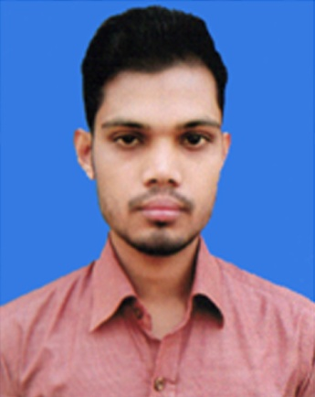
CURRICULUM VITAE

Photo
OF
ABDUR RAZZAK
+8801883926411
 abdurrazzak717282@gmail.com

Career Objectives:

Willing to build up career in a challenging position and to prove myself as a quick learner and highly energetic person to face any challenge in the Information Civil Technology sector where the contribution will be acknowledged, if would be given an opportunity.

Educational Qualification:

- Diploma-In-Engineering: -
- Name of the institution : Sirajganj Ideal Textile Engineering Institute (SITEI)
- Board : Bangladesh Technical Education Board, Dhaka.
- Department : Civil Technology
- Passing year : 2017
- Obtained C.G.P. A : 3.56 (out of 4.00)

- Secondary School Certificate (SSC): -
- Name of the institution : Betil M.L High School, Sirajganj.
- Board : Rajshahi
- Group : Science
- Passing year : 2013
- Obtained G.P. A : 4.13 (out of 5.00)

Industrial training & practice:

- Organization Name : " PWD Bogra Division"
- Address : Bogra.
- Duration : Three Months.
Computer Skill:

- Computer Office Application, Auto CAD 2D, 3D Max, Internet Browsing.
Language Skills:

Language | Writing | Reading | Listening | Speaking
Bengali | Excellent | Excellent | Excellent | Good
English | Excellent | Excellent | Excellent | Good

Relevant Skills:

- Capable of working in a team as well as independently.
- Comfortable with working long hours in the site as well as an organization.
- Fluent in speaking, writing & listening in both English and Bengali.

Personal Information:

- Name : Abdur Razzak
- Father’s Name : Md. Bojlur Rahman
- Mother’s Name : Jahanara Begum
- Nationality : Bangladeshi (by birth).
- Religion : Islam
- Sex : Male.
- Marital Status : Unmarried.
- Date of Birth : 02/01/1997
- Height : 5'-6''
- Weight : 54 kg.
- Blood Group : B+ (positive).
- Birth Place : Sirajganj.

Present Address:
- Village : Vangabari
- Post Office : Gopalpur,
- Police Station : Belkuchi,
- District : Sirajganj.

Permanent Address:
- Village : Vangabari,
- Post Office : Gopalpur,
- Police Station : Belkuchi,
- District : Sirajganj.

Reference:

Md. Nazmul Hasan
Sub-Assistant Engineer
PWD, Bogra.
Mobile: 01553296146, 01790660424

Interest
I am able to work in a team environment, reading, playing and traveling and in
Challenging work.

Declaration:
“I do hereby declare and certify that all the information stated above in this curriculum vitae are true and complete to the best of my knowledge and belief”.



Date: ……………………
Abdur Razzak

