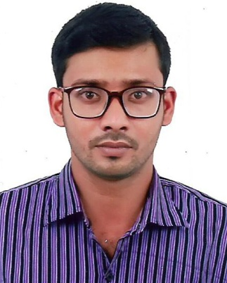
CURRICULUM VITAE (CV)
Md. Raihanul Islam
Contact:01941 604 039
C/O: Md. Shoriful Islam & Most. Liju Begum

CAREER OBJECTIVE:

Have a strong desire to work in such a site where I can develop my career through putting my skills, learning experience and all of my educational qualifications. To achieve this aim I’m fully determined to show honesty, efficiency and sincerity up to my optimal level.

ACADEMIC QUALIFICATIONS:

- Diploma in Mechanical Engineer :
Institution : Pabna Polytechnic Institute.
Session : 2009-2010
Result : CGPA- 2.97 (on scale of 4.00)
Subject/Group : Mechanical
Passing Year : 2013
Board : BTEB
Duration : 04 Year’s

- Secondary School Certificate (S.S.C):
Institution : Kishoreganj Shishu Nikaton High School.
Board : Dinajpur
Session : 2007-2008
Group : Science
Result : GPA 4.63 (on scale 5.00)
Passing Year : 2009

WORKING EXPRIENCE :

Name of Company | Post Name | Responsibility | Duration
Panama Water Ltd. | SAE (Sub-Assistant Engineer) | Shift In charge  (Production) | 01 Years (2014-2015)
Pran RFL Group | Sub-Assistant Manager | Shift In charge  (Production) | 04 Years (2015-2019)

INDUSTRIAL TRANING:

- Institute Name : Bangladesh Railway Saidpur Industry.
Course Name : Machanical Engineering.
Duration : 06 Months.

COMPUTER SKILLS :

- 06 Months Competing Course of “Computer Office Application Program”.
(M/S Word, M/S Excel, M/S Power Point, E-mail & Internet Browsing).
LANGUAGE PROFICIENCY:

- Bangla Language fluent in spelling, Writing & listening.
- English language fluent in spelling, Writing & listening.

Personal Details:
PERSONAL DETAILS:
Full Name : Md. Raihanul Islam
Father’s Name : Md. Shoriful Islam
Mother’s Name : Most. Liju Begum
Present Address : Vill: Gonpara, Post: Barabhita, Post code: 5320,
Upazilla: Kishorigonj, District: Nilphamari.
Permanent Address : Vill: Gonpara, Post: Barabhita, Post code: 5320,
Upazilla: Kishorigonj, District: Nilphamari.
Nationality : Bangladeshi
Date of Birth : 25 Nov 1994
National ID No : 506 903 8056
Gender : Male
Religion : Islam
Marital Status : Married
Current Location : Barabhita, Kishoreganj, Nilphamari.
Personal Mobile No : 01941 604 039
REFERENCE:

01. Md. Mizanur Rahman 02. Md. Bipul Mia
Post Name : Deputy Secretary Post Name : Assistant Police Officer
Office of the Council of Ministers Bangladesh Police, Tajgaon Thana, Dhaka
Mob : 01719 710 123 Mob. 01719 414 945
DECLARATION:

I, the undersigned, certify that to the best of my knowledge and belief, this CV correctly describes me, my qualifications and my experience. I understand that any willful misstatement described herein may lead to my disqualification or dismissal, if engaged.

Applicant’s Signature
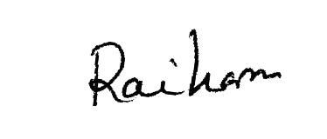

(Md. Raihanul Islam)
Date:

