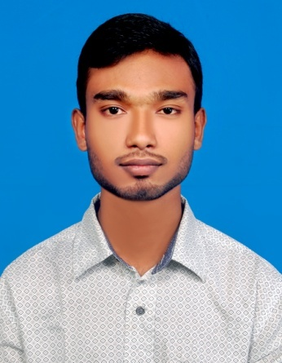
Curriculum vitae
Of
Maruf Abdulla Nobel
Contact Address :
House #19, Road #5, Block #E
Section #12, Mirpur
Dhaka-1216, Bangladesh
Contact No: +8801635171743
E-mail:marufabdulla.n@gmail.com
CAREER OBJECTIVE:
To build a challenging career as devoted trustworthy as well as efficient work in a daynamic private that will provids a learned environment and encourage of my efficiency .I like to take the rewarding opportunities to tackle problems arising particularity in private sector to provide myself as dynamic personnel.
EDUCATIONAL BACKGROUND:
Name of Degree : Secondary school Cretificate (S S C )
Institute : Bishoykhali S M School & College
Board : Jessore
Result : GPA 3.56 out of 5.00
Group : Science
Year of Passing : 2014

Name of Degree : Diploma in-engineering
Institute : Novel Polytechnic & Textile Institute
Board : Bangaldesh Technical Board, Dhaka
Result : CGPA 2.94 out of 4.00
Department : Civil Technology
Year of Passing : 2018

LANGUAGE PROFICIENCY :
Name of Language Speaking Reading Writing Listening
- Bangla Excellent Excellent Excellent Excellent
- English Good Good Good Good

SELF-ASSESSMENT:
My strength includes willingness to learn and accept responsibilities apply myself honesty to work at hand.
- Strong motivation and commitment for work .
- Endurance to work for long hours and under pressure assessment .
- Ability to work dependently as well as a team member .
- Commendable communication and presentation skill .
- Eagerness to learn anything new and flair to travel in pursuit of knowledge.
COMPUTER SKILLS:
Office: Microsoft Word, Excel, Power- Point
Graphics Design: Adobe Photoshop cc 2015, Illustrator cc 2015
Civil Software : AutoCad-2D,3D, Revit- 2D,3D, SketchUp-3D
Internet: E-mail, Browing
INTEREST :
- Reading Poem & Novel related books gather knowledge.
- Traveling, Playing.
- Internet Browsing.
EXPERIENCE:
Job Titel: Cad Operator
Dates From-To: 2017-2019
Company Name: Building Planer
PERSONAL DETAIL :
- Father’s name: Md.Shahidul Islam
- Mother’s name: Nahida Islam
- Date of Birth: 08/10/1997
- Age: 21
- Permanent Address: Vill:Bishoykhali, P.O:Kharikhali, P.S:Jhenaidah, Dist:Jhenaidah

- Nationality: Bangladeshi (by bath)
- Sex: Male
- Marital Status: Unmarride
- Religion: Islam (sunni)
- Height: 5’-4.5’’
- Weight: 50 kg

CERTIFICATION:
I, the undersigned, certify that according to the best of my knowledge and belief, this resume correctly describes my qualifications and me.

Signature: Nobel
Date:2/06/2019

