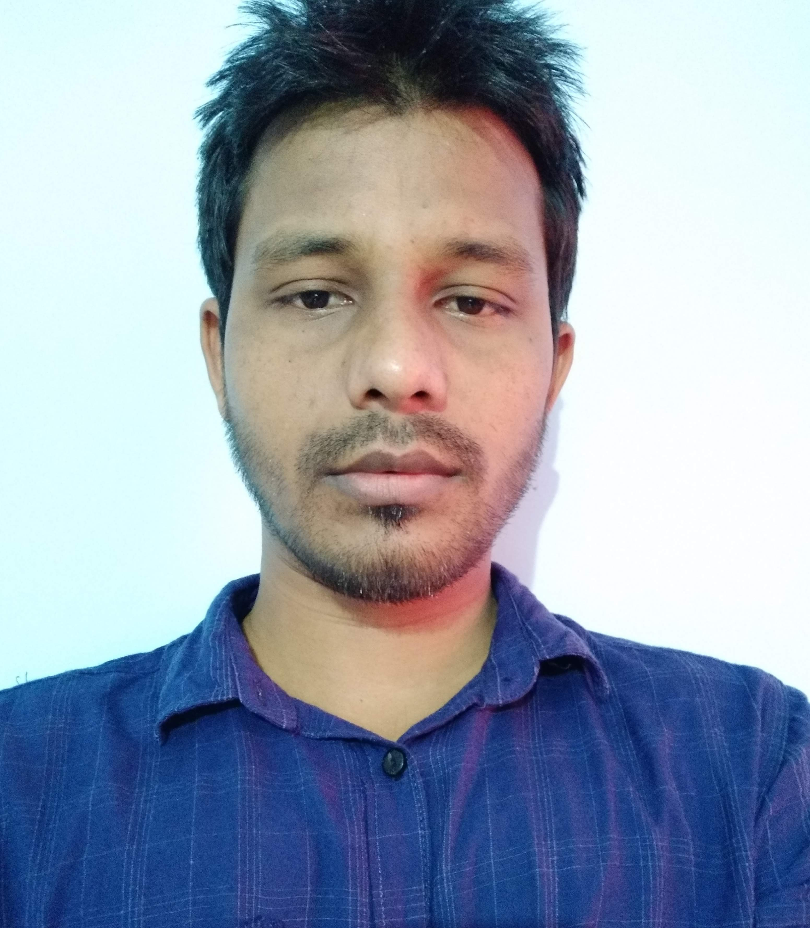
SUBROTO ROY
Khuliya para,nilima 52/4
Sylhet

Mobile: +8801714-528436
Email : subrotor436@gmail.com

CAREER  OBJECTIVE | I want to work for an organization that provides me enough challenge and opportunity to grow and trust me with responsibilities. I will be working with the best of my abilities and make myself an integral part of the organization.
SCHOLASTIC  RECORDS | Degree  Department  University  Year CGPA  Degree  Group  Institution  Year of passing  CGPA  Degree  Group  School  Year  CGPA | : Honours  : Computer Science & Engineering  : Metropolitan University,Sylhet  : 2014  : 3.00 out of 4.00  : HSC (Higher Secondary Certificate)  : Science  : Govt. College Sunamgonj  : 2008  : 2.80 out of 5.00  : SSC (Secondary School Certificate)  : Science  : Govt. Jubilee High School, Sunamgonj  : 2006  : 3.38 out of 5.00

SPECIAL SKILLS | Protect the company from market Leader, Competitor, Follower and Nicher.  Interpersonal relationship Skill.  Ability to rapidly assimilate and implement new ideas
LANGUAGE  PROFICIENCY | Language Writing Reading Speaking  Bengali Excellent Excellent Excellent  English Good Good Good
COMPUTER  LITERACY | Being conversant in several computer languages such as  Ms-Word, Ms- Excel, Power Point etc.  PHP, MY SQL,HTML,CSS etc.
PERSONAL  INFORMATION | Full Name : Subroto Ranjan Roy  Father’s Name : Subodh Ranjan Roy  Mother’s Name :Suprova Roy  Date of Birth : 1th January 1990  Sex : Male  Religion : Hindu  Marital Status : Unmarried  Nationality : Bangladeshi (By Birth)  Blood Group : O (+Ve)
PERMANENT  ADDRESS | C/o –Subodh Roy  Vill – Jamalgor  P.o – Tahirpur  P.s – Tahirpur  Dist. – Sunamgonj.
PRESENT  ADDRESS | C/O- Subroto Ranjan Roy  Khuliya para,nilima 52/4  Sylhet  Bangladesh
 | I have been work SAMSUNG Mobile as a retail development office since 01/01/2015 to 30/10/2017  I have been work SAMSUNG Mobile as a territory sellout executive since 01/11/2017 to 30/02/2018  I have been work vivo Mobile as a territory manager since 01/05/2018 to 30/12/2018  I have been work Lava Mobile as aTerritory Manager since 01/01/2019 to 30/09/2019
  Work Experience | RDO(SAMSUNG Mobile)  TSE(SAMSUNG Mobile)  TM(vivo Mobile)  TM(Lava Mobile)

Sincerely Yours,

Subroto Ranjan Roy

