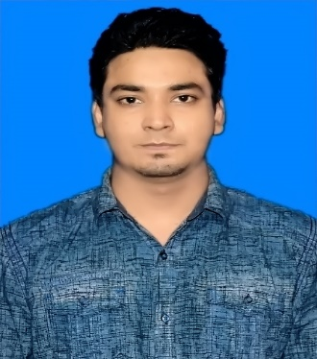

MD. Saeid Hussain
Address: H# 645/3, West Kazi Para Mirpur-10, Dhaka-1216.
Mobile No 1:+88 01938616674
Mobile No 2 :+8801906645264
e-mail : hussainsaeid@gmail.com

Career Objective:
To work with an organization and prove the potentiality through hard work, efficiency, enthusiasm and integrity. To attain practical experience that can be used to further improvement of the organization as well as for development work.

Special Qualification:
• Strong verbal and personal communication skills. • Decision making, critical thinking.• Self-motivated, initiative, maintains a high level of energy.• Organization and prioritization skills.• Tolerant and flexible, adjusts to situations.

Employment History:
Total Year of Experience : 1 Year(s)

Manager of Pos System Solution
Shwapno Retailer Shop
Dhanmondi 27, Dhaka.
14th August 2017 to 30th July 2018

Academic Qualification:
Exam Title | Concentration/Major | Institute | Result | Pass. Year | Duration
BBA | Accounting | National University | CGPA:2.84  out of 4 | 2017 | 4
HSC | Business Studies | Jessore Cantonment College, Jessore | CGPA:4.90  out of 5 | 2013 | 2
SSC | Business Studies | SingaTilkhari Secondary School, Magura | GPA: 5.00  out of 5 | 2011

Training Summary:
Training Title | Topic | Institute | Country | Year
Academic Course | Secritarial Science | Cantonment College Jessore | Bangladesh | 2015
Corporate Training | POS Managemnt | ACI Group | Bangladesh | 2018
Academic Training | PL Course | Boys Souct | Bangladesh | 2010

Career and Application Information:
Available For | : | Full Time
Preferred Job Category | : | Corporate Sales & Business Development & Accounting management
Preferred District | : | Dhaka
Preferred Country | : | USA, Australia
Preferred Organization Types | : | Group of Companies, ISP Company & Network Companies, Banks, IT Enabled Service

Personal Details :
Father's Name | : | Md. Abdul Ohab
Mother's Name | : | Nazma Naznin
Date of Birth | : | September 21, 1995
Gender | : | Male
Marital Status | : | Single
Nationality | : | Bangladeshi
National Id No. | : | 19954114795000044
Religion | : | Islam
Permanent Address | : | Sector # 7, House # 13, Post # New town, P.S # Kotoali, Dist # Jessore(7400).
Current Location | : | Dhaka

Reference (s):
Name | : | Dr. Md. Abul Hashem
Organization | : | Dental Care Centre
Designation | : | BDS PMH,Phd
Head Office Address | : | ADC Empire plaza (2nd floor) 183,satmasjid Road, Dhanmondi, Dhaka-1209
Mobile | : | +8801712167830
Relation | : | Uncle.

I am declaring that above written information is true as my concern.

Yours Sincerely

------------------------------
(Md. Saeid Hussain)

