Curriculum Vitae
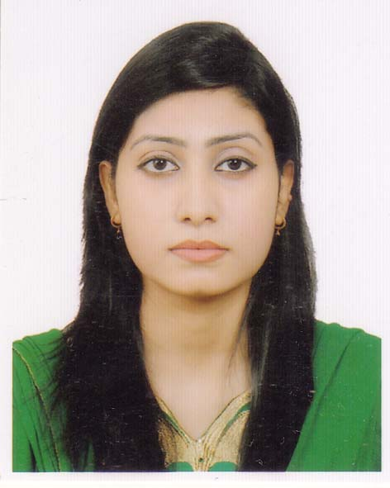

Jannat- E- Jasmin Chowdhury
Address: House no,121,Mirboxtula, Sylhet-3100
Mobile: 01745-709983
E-mail Address: jessychy001@gmail.com
Objectives:
I am a highly energetic and motivated individual wishing to use academic and practical knowledge to pursue a long career path and having the intention to work with sincerity, honesty and to face challenges of time to contribute to the nation and economy.
Personal Information:
Father’s Name : AftaburRazaChowdhury
Mother’s Name :Shamsun Naher Chowdhury
Religion :Muslim
Marital Status :Unmarried
Nationality :Bangladeshi
Date of Birth :5thSeptember 1988
Place of Birth : Sylhet
Country :Bangladesh

Education:
Master of Business Administration (MBA)
- Institution : Metropolitan University, Sylhet
- Passing Year : 2017
- Result : 3.56 (Out of 4)
- Major : Marketing

Bachelor of Business Administration (BBA)
- Institution :Metropolitan University , Sylhet
- Passing Year : 2014
- Result :3.85(Out of 4)
- Major : Marketing

Higher Secondary Certificate (H.S.C)
- Institution :Sylhet Govt.Women’s College, Sylhet
- Board : Sylhet
- Group : Science
- Passing Year : 2006
- Result : 3.2

Secondary School Certificate (S.S.C)
- Institution :Govt.Girls High School, Sylhet
- Board :Sylhet
- Group :Science
- Passing Year : 2004
- Result : 4.06
Interest:
- Traveling, Reading Books, Gardening and internet browsing.
Computer skills:
- Microsoft word, Microsoft Excel, Microsoft PowerPoint, Browning etc.
Language Proficiency:
- Good speaking, reading and writing skills in English and Bengali
Reference:
1. Md.Jamal Uddin  Assistant Professor,  Dept.of BusinessAdministration  Metropolitan University,Sylhet  Cell Phone : 01558347255 |  | 2. Debashish Roy  Assistant Professor,  Dept.of BusinessAdministration  Metropolitan University,Sylhet  Cell Phone: 01717534079

I hereby admit that the above mentioned information is true in the best of my knowledge. I would be personality liable for any deviations.
Jannat- E- Jasmin Chowdhury

