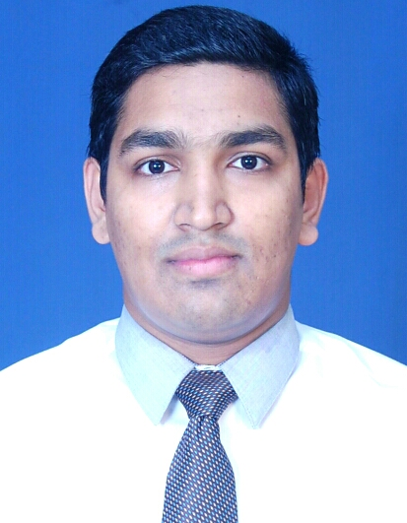
MD. SIFATH KHAN
Contact Address
Prottoy 44/A, Alomtula,
Sylhet-3100
Cell: +8801737769035
+8801612238789
E-mail:khan.sifath@yahoo.com

Career Objective
I am willing to work where I can share my knowledge and energy to the fullest extent in such an environment that will give me scope to enrich myself with new challenges and opportunities.

Scholastic Status

M.A(Master of Arts)
Subject : English
Result : GPA-3.52
Passing Year : 2016
Institute : North East University Bangladesh, Sylhet.
B.A (Bachelor of Arts)
Subject : English.
Result : GPA-3.09
Passing Year : 2013
Institute : Leading University, Sylhet.
H.S.C (Higher Secondary Certificate)
Group : Business Studies
Board : Sylhet
Result : GPA-2.60
Passing Year : 2008
Institute : Madan Mohan College, Sylhet.
S.S.C (Secondary School Certificate)
Group : Business Studies
Board : Sylhet
Result : GPA-2.75
Passing Year : 2005
Institute : The Aided High School, Sylhet.

Computer Skills:
Have very good knowledge of operating Computer.

Language Proficiency:

Excellent in reading, speaking and writing both in English and Bangla .

Experience:
1) Worked as a Branch Sales Executive in Eastern Bank from 3 March, 2014-8 December, 2014.
2) Worked as a Business Executive in FAS Finance and Investment from 1 January, 2017-
31 July 2017.
3) Worked as a Relationship Officer (Permanent) in Brac Bank Limited from 20 August, 2017-27 August, 2018.
4) Presently I am working as a Customer Relationship Officer in Musketeers Business Process Outsourcing.

Pastime:
Photography; Playing Cricket, Badminton, Singing, Drawing, Roaming; and listening Music.

Personal Information:

- Father’s name : Md. Azmal Khan
- Mother’s name : Syeda Khatun
- Permanent Address : 44/A-Prottoy, Alomtula, Sylhet-3100
- Date of Birth : November12, 1988
- Nationality : Bangladeshi
- Sex : Male
- Religion : Islam
- Marital : Married

References:
Md. Shamsul Kabir  Head (Acting), Department of English  North East University Bangladesh(NEUB)  Phone: +8801819560206  Email:shamu174@hotmail.com | Nasif Md. Muiz Ul Marjan  Branch In-Charge  Prime Bank Investment Ltd.  Casablanca Tower(1st Floor)  982,Dargah Gate, Sylhet-3100.  Phone: +881715199726  Email: nasif@pbil.com.bd

Certification:

I, the undersigned, certify that to the best of my knowledge and belief, these data correctly described my qualification, my experience and me. I undersigned that my willful misstatement described herein may lead to my disqualification or dismissal.



____________________________
Md. Sifath Khan

