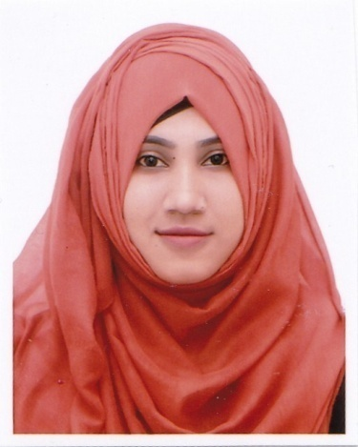
KHADEJA CHOUDHURY RUBI
Phone: +8801763100656
Address: Tatipara, Zindabazar, Sylhet.
Email:chowdhuryrubi71@gmail.com
Skype id: Rubii Chowdhury

Career Objectives:

To obtain an honorable position in educational sector that will provide present and future opportunities for growth, development and to use my educational knowledge & experience which help to increase social value of nation and to dedicate my whole effort to achieve institutional goal.

Educational Qualification

(B.sc Hon’s)
Institute Name : Metropolitan University, Sylhet.
Subject : CSE
Result : 3.32 (CGPA) Above all Semester
Year of Passing : Dec 2017

Higher Secondary Certificate (H S C)
Institute Name : Scholarshome girls school & College, Sylhet
Educational Board : Sylhet
Result : 3.90
Group : Science
Year of Passing : 2013

Secondary School Certificate (S S C)
Institute Name : Hakaluki High School, Moulvibazar,Sylhet
Educational Board : Sylhet
Result : 4.56
Group : Science
Year of Passing : 2011

Language Proficiency

- Excellent command over Bangle in reading, writing, listening and speaking good command over English in reading, writing, listening and speaking.

Computer Literacy

- I am deeply conversant with MS. Word, MS. Excel and MS. PowerPoint etc
- Html5, Css3,Bootstrap, Php, Mysql etc.

Interests

- Reading books, Listening Music,Internet Browsing, Traveling.

Extra curricular Activities

- Member of Metropolitan Rover Scout.

Self Assessment

- Willing to learn and build-up career by accepting responsibilities on all aspects.
- Energetic, Sincere, Hard working and Dutiful.
- Able to set prioritize and routine tasks.
- Able to work at any time any place

Experience
- Worked at careerzone Sylhet, as a chief consultant from 1 December 2017 to 30 November 2018.

Personal Information

Name : Khadeja Choudhury Rubi
Father’s Name : Md. Abdur Sakur Choudhury
Mother’s Name : Amina Begum Choudhury
Date of Birth : 22 Feb, 1994
Marital Status : Unmarried
Religion : Islam
Gender : Female
Nationality : Bangladeshi
Permanent Address : Vill: Gogra, P.O- Hakaluki, P.S- Barlekha, Dist: Moulivibazar, Bangladesh

Declaration

I hereby declare myself that all the statement in this C.V is authentic complete and correct of the best of my knowledge and belief.

Reference
1. MD Kamor Uddin Deputy Director  Bangladesh Bank  Taltola,Sylhet  Mobile:01711344106 | 2. Rofiqul Bari  Senior Teacher  Bridge Academy, Gobindaganj  Chhatak, Sunamganj  E-mail: ms_bari@hotmail.com  Mobile : 01737627537

