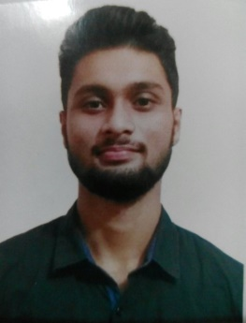

MOHAI MINUL ABID

OBJECTIVE
Myself an enterprising young professional intending to continue my development with a reputable organization with professional work driven environment where I can expand my learning, knowledge, and skills which would secure a challenging position fulfilling organizational goals.

CONTACT
 01303611145

abidratul80@gamil.com
804-West Kazipara, Mirpur, Dhaka-1216

EDUCATION
- B A Honours in English (Ongoing), Dhaka College affiliated with Dhaka University
Session (2019-2020)
- Higher Secondary School Certificate (Arts) , Dinajpur Board.
GPA 4.32/5.00 (2017-2019)
- Secondary School Certificate (Science) , Dinajpur Board.
GPA 4.41/5.00 (2013-2017)

SKILLS

COMMUNICATION
LEADERSHIP
PRESENTATION
TEAMWORK
ORGANIZATION
PHOTOGRAPHY

TRAINING & CERTIFICATION
- Associate Diploma in Computer Science & Tech. Jan. 2018- June 2018
Institute of Information Technology, Gaibandha Sadar, Gaibandha.

SOFTWARE

MS OFFICE
PHOTOSHOP
CODE BLOCK

REFERENCES
Md. Ariful Haq
Senior Executive, Quality Control
Orion Pharma Ltd
T. +8801918556729
E. m.arifulplsc@gmail.com

PERSONAL

Birth year JUNE 2001
Marital Status : Unmarried
Nationality : Bangladeshi
Languages : English, Bengali
Religion : Islam
Permanent Address
Village : College para
Post office : Gaibandha Sadar
Post Code : 5700
Upazila : Gaibandha Sadar

District : Gaibandha

