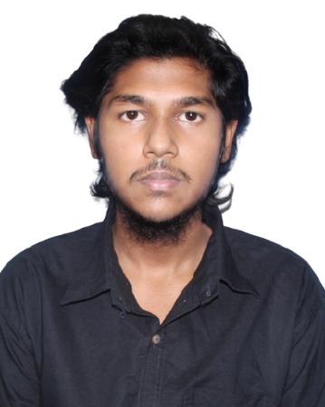
Curriculum vitae of
Sifat Seniabad
Current address: House:55, Farmgate - Tejturi Bazar , Dhaka-1215.

Cell : 01891-994017
Email : Crispydotexe@gmail.com

PERSONAL QUALIFICATION

- Strong collaborative skills.
- Honest, hardworking & eager to learn.
- Ability to cope with the changing environment..
- Advance gaming.

EDUCATIONAL QUALIFICATION

Secondary School Certificate (S.S.C)

Name of the Institute : Tejgaon Govt High School
Group : Commerce
Passing Year : Running
Board : Dhaka
Obtained GPA : Appeared
Junior School Certificate (J.S.C)

Name of the Institute : Tejgaon Govt High School
Group : Commerce
Passing Year : 2019
Board : Dhaka
Obtained GPA : 3.71

COMPUTER SKILLS
- Operating System: Windows.
- Video Editing: Basic level.
- Gaming: CS: GO, Rainbow six siege, Call of Duty.
- Social Media:Facebok,Instagram.

PERSONAL DETAILS

Full Name : Sifat Seniabad
Father’s Name : Md. Abdul Mannan
Mother’s Name : Ratna
Permanent Address : Vill: Bonogram, P.O: Medakul
P.S: Kalkini, Dist: Madaripur.
Nationality : Bangladeshi
Date of Birth : 10/10/2005

Religion : Islam

Gender : Male

INTERESTS/HOBBIES

- Sitting whole life with computer
- Pet lover
- Gaming
- Eating
- Trying to Learning new things about computer.
- Enjoy to research

I declare that all the given information is true and all supported documents would be provided upon request.

