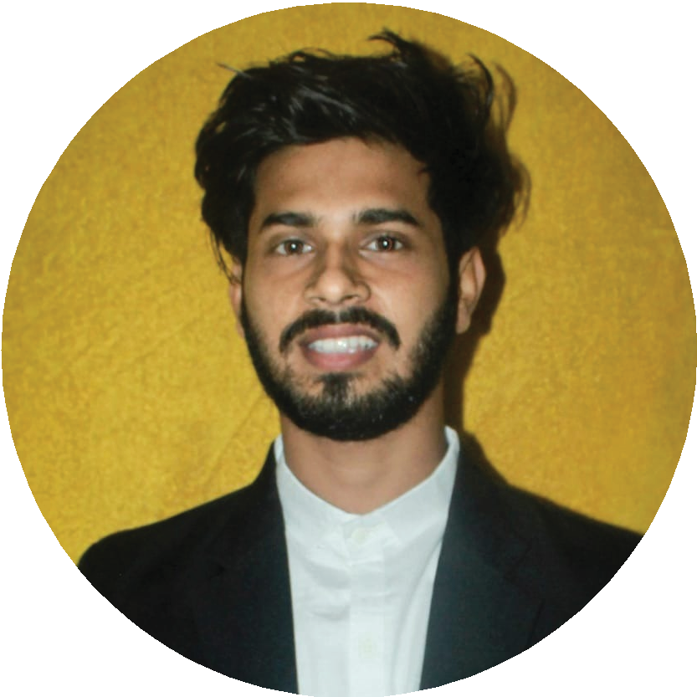EDUCATION

MD OBAIDUR RAHMAN HOWLADAR
2021

2016

2014
B.Sc in Computer Science and Engineering
CGPA : 3.01 out of 4.00
Institution : Laeading University
Higher Secondary School Certificate (H.S.C)- Institution : Sylhet Govt. Model School & College GPA : 4.58 out of 5.00

Secondary School Certificate (S.S.C)
GPA : 4.44 out of 5.00
Institution : Rajkumar Edward Institution Bajitpur, Madaripur

CAREER PROFILE
I have clear logical mind with a practicul approach to problem solving and to see things through to comple- tion. i graduate with a B.Sc in CSE from Leading University. Besides, i have been working in the field fot 3 years as a designer of Berger illusion and also teaching multiple tuitions. I have excellent communication skill, enabling me to effectively communica-

EXPERIENCE

February 2017- present (per-time)

January 2019- present (per-time)

Company Name : Berger Illusions (home decor)
Position : Executive Designing Manager

Company Name: Gadgetveli.com
(trusted online shop)
Position : Brand Manager

tive with wide rang of people.

EXTRA CURRICULAR ACTIVITIES

LANGUAGE
Bengali English

I have organized about 15 events a year on behalf of Leading University's Computer Club, Cultural Club, Photographic Society and Debating Club. Where 5,000 people have participated directly and 1 lakh people have participated online.

CONTACT
Lamapara Shibgonj, Sylhet

+8801724412500

obaidurr219@gmail.com

https://www.facebook.com/ shopnil5300

https://www.linkedin.com/in
/md-obaidur-rahman-howlader
-012b13193
I have been working with neglected street children for about 5 years. Where I am telling the hidden stories of the lives of these children and helping them a little bit.

HARD SKILLS

Leadership Problem-Solving Communication Teamawork Adaptability Creativity

SOFT SKILLS

Marketing Design
Data Analysis Project Management Negotiation

COMPUTER SKILLS

MS Office Social Media Spreadsheets Software Skill Writings Skills

ACHIEVEMENT

Beautiful Bangladesh Campus Photography Competition I 2020
Position- 2nd
LU Intra Debate Championship I 2019
Position- Champion

HOBBIES

Photography Writing Painting Travelling

REFERENCE

Minhazul Haque Riad
Assistant Professor
Dept.of Computer Science & Engineering Leading University minhazulriad@yahoo.com
+8801678174660
Abu Bakar Molla Design Manager Berger illusions Shahi Eidgah, Sylhet
bakarmolla18@gmail.com
+8801710561009

