MD. KAWSER AHMED
Anandapur, Anandapur Mohila College, Adarsha Sadar, Cumilla.
Mobile: +880 1521230812
E-mail: kawser.cse.ru@gmail.com

GitHub: www.github.com/KAWSER04

Carrier Objectives
To work for an organization which provides me the opportunity to improve my skills and knowledge to growth along with the organization objective.I am seeking for an opportunity where I have to utilize my skills and knowledge efficiently for the organizational growth.

Summary
- Excellent interpersonal communication skill.
- Energetic, self-confident.
- Passionate to learn new technologies and Quick IT Learner.
- Can work as part of a team or independently also Excellent Team Leader.
- Fully committed and determined in achieving my goals.
- Sound Presentation Skill also Like to Meet & Take Challenges.

Job Experience

- Teaching Assistant ( October 2018 – Present)
Advanced ICT Care, Rajshahi
Duties/Responsibilities
- Teaching MATH & ICT.
- Assisting in any queries.
- Following the specific tasks set by the Managing Director.

- Teaching Assistant ( December 2017 – September 2018)
Katakhali Jenoin Coaching, Rajshahi
Duties/Responsibilities
- Teaching English & ICT to the O’ level students.
- Following the specific tasks set by the Managing Director.

Working Knowledge:

 | Networking Achievements | : | - Practical Knowledge On Local Area Network (LAN)  - Practical Knowledge On Wide Area Network (WAN)  - Design and Development the Networking  - Practical Knowledge on LINUX ISP setup  - CCNA Routing and Switching.
 | Databases | : | - Basic knowledge of MS SQL Server 2008, MS Access.
 | Computer Hardware | : | - Computer Hardware assembling.  - Practical knowledge in many computers Component And its Use.  - Computer trouble shooting and Servicing  - And many More about computer.

Education Qualification
Qualification | Institution |  | Passing Year | CGPA/GPA
B.Sc in Computer Science & Engineering (CSE) | Rajshahi University, Rajshahi |  | 8th semester  complete | Not published
H.S.C. | Cumilla Government College, Cumilla |  | 2016 | 4.92  (out of 5.00)
S.S.C | Government Laboratory High School, Cumilla |  | 2014 | 5.00  (out of 5.00)

Skills
Skill | Fields
Operating System | All Operating System of Windows System.
Language | C, C++, JAVA, HTML5, CSS3.
Database | Oracle-11g,PL/SQL,SQL Server-2014,MYSQL
Networking | Switches,Routers,IP configuration.
MS Office | MS Word, MS Excel, MS Powerpoint.

Projects
Name | Technology
Schedular Alarm | C, C++, JAVA.

Language Proficiency
Language | Reading | Writing | Speaking
Bengali(Native) | Excellent | Excellent | Excellent
English | Very Good | Very Good | Very Good

Hobbies and interests
Playing Cricket, Football & Travelling to historical places

Personal Information
Name : | MD. Kawser Ahmed
Father’s name : | Jamal Uddin
Mother’s name : | Mafia Begum
Nationality : | Bangladeshi by birth
Sex : | Male
Marital Status : | Married
Date of birth : | 15th January,1998.
Religion : | Islam
Blood Group : | O+

Address
Permanent Address | Present Address
Anandapur, Anandapur Mohila College, Adarsha Sadar, Cumilla. | Anandapur, Anandapur Mohila College, Adarsha Sadar, Cumilla.

References
Dr. Md. Ekramul Hamid  Professor  Dept. of CSE  Rajshahi University  Cell no# 01726420004  Email Address : ekram_hamid@yahoo.com | Dr. A R Shoyeb A. Siddique  Professor  Dept. of CSE  Rajshahi University  Cell no# 01711348183  Email Address: shoyeb_siddique@yahoo.com

Declaration

I hereby declare that the information given above is correct and complete to the best of my knowledge.
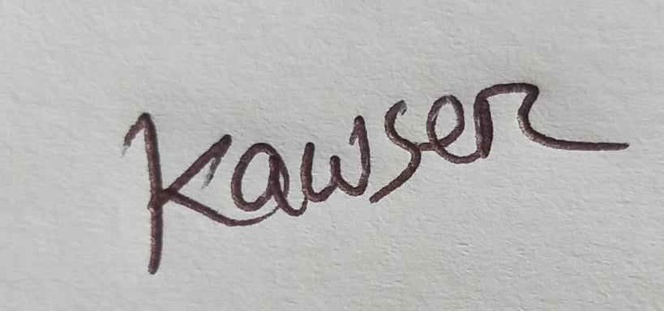

Signature

