Curiculam Vitae
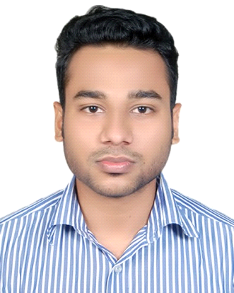

Rashu Debnath
Contact Numbe : +8801687230982
Email : rashud47@gmail.com
Present Address: Dhariapara,
Sylhet

Career Objectives:

Looking forward to a challenging career in the professional world where I would be able to utilize my knowledge and skills through dedication, challenge and growth-oriented activities. To work in a meaningful environment where I can utilize my creativity and enthusiasm to develop myself towards my aims effectively and efficiently.

Academic Qualification:

Exam Title | Concentration/Major | Institute | Result | Pas.Year
B.Sc.(Hons.) | Computer Science & Engineering(CSE) | Leading University | CGPA: 3.38  (out of 4) | 2018
H.S.C | Science Studies | Sreemangal Govt.College | GPA: 4.5 | 2014
S.S.C | Science Studies | B.T.R.I high school | GPA:4.5 | 2012

Trainning Details:

LICT TOP-UP IT Training for Android Apps

Trainning Summary:

Training Title | Topic | Institute | Country | Location | Year
Foundation Skill | Soft skill | LICT | Bangladesh | Sylhet Science and Technology college,Sylhet | 2017

Experience

Fresher

Projects Name:

- Android Apps: BD Info
-from this app the user can know about different Bangladesh’s Tourist attraction Place, Hotel, Restaurant, Hospital and University information.

- Android Apps: Tution Media

- Android Apps: BCS Guideline

Key Strengths:

- Efficient in preparing reports and delivering presentations.
- Hard working, Punctual, Dedicated and Calm.
- Fluent in Bangla and English
- Work well under pressure both independently and in a team.
- Quick learner with good grasping ability.

Weaknesses:

- I am straight forward, concentrate on a work at a time. I am too much perfectionist and it wastes my time.

Interests & Hobbies:

- Android Apps Development
- Reading books
- Watching movies
- Travelling

Language Proficiency:

Excellent Reading, Speaking and Writing skills in Bangla.
Excellent Reading, Speaking and Writing skills in English.

Detailed Information:

Father’s Name | : | Rathul Debnath
Mother’s Name | : | Niva Rani Debi
Date of Birth | : | 12-04-1996
Marital Status | : | Unmarried
Nationality | : | Bangladeshi
Blood group | : | A positive(A+)
Permanent Address | : | Barlekha,Moulvibazar,Sylhet

DECLARATION:

I do here by declare that the particulars provide here are true to the best of my knowledge and no misinformation is given.

Rashu

