Mahbubul Islam  House: 56/21; Muhona Block-A, Pathantula, Sylhet-3100  +8801735928899  islamfaiyaj1993@gmail.com | 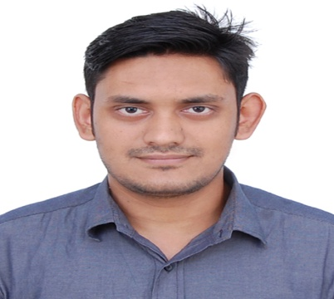

Career Summary
Two months of experience as a Customer Care Representative at Banglalink Service Point provide customer service and face-to-face sales and three months of internship experience of L/C, Remittance, and general activity. Aiming to help achieve company goals and take on more responsibility as quickly as possible

- MBA in Finance & Banking, 2017  Leading University, Sylhet  CGPA: 3.94 out of 4.00 | - HSC in Science, 2012  Fenchuganj Degree College, Sylhet  GPA: 4.60 out of 5.00
- BBA in Finance & Banking, 2016  Leading University, Sylhet  CGPA: 3.53 out of 4.00 | - SSC in Science, 2010  Kasim Ali High School, Sylhet  GPA: 4.63 out of 5.00
Academic Qualification

Job Experience
CCR (BSP) | Banglalink | www.banglalink.net
(A telecommunication company in Bangladesh)
Uposhohor, Sylhet | From August 2017 to September 2017
Job Responsibility:
- Attracts potential customers by answering product and service questions.
- Resolves product or service problems by clarifying the customer's complaint.
- Selecting and explaining the best solution to solve the problem.
- Prepares product or service reports by collecting and analyzing customer information.

Extra Curricular Activities
- Cadet of Bangladesh National Cadet Corps (BNCC), at Fenchuganj Degree College & Leading University Platoon.
- I was the volunteer of the 2nd Convocation Program of Leading University.
Training
- LICT TOP-UP IT Training for Digital Marketing.
Duration: 160 hours, 2017

- Internship Program at Uttara Bank Limited, Sylhet Branch.
Duration: 3 months (From September 2016 to December 2016)

- BNCC Annual Training Camp 2010-11 under Mainamati Regiment, Comella.
Duration: 15 days, 2011

- Basic Computer Training Course
Duration: 3 months, (From August 2010 to October 2010)

Personal Details
Father’s Name : Abdul Khalique
Mother’s Name : Husneara Begum
Date of Birth : Thursday, November 18, 1993
Blood Group : $O^{+}$
Gender : Male
Nationality : Bangladeshi
National ID : 19939113571000019
Marital Status : Unmarried
Religion : Islam
Permanent Address : Village: Maijgaon, Thana & PO: Fenchugang- 3116, Sylhet

English Proficiency
Reading-High, Writing-High, Speaking-High
Major Dilara Begum  AFNS Officer  CMH, Jalalabad  Contract:+8801712-947753 | Dr. Tahmina Jahan Liza  Lecturer  Jalalabad Ragib Rabeya Medical College  Anatomy Department, Sylhet  Contact: +8801719-817439
Reference
Signature
Date: February 12, 2018 | ____________________  Mahbubul Islam
I do here by declare that above information is true and correctly describes my qualifications and myself to the best of my knowledge.

