Bulbul Kumar Deb  House: 343/1,Uttar Bagbari, Sylhet-3100  +8801721228300  bulbuldeb85@gmail.com | 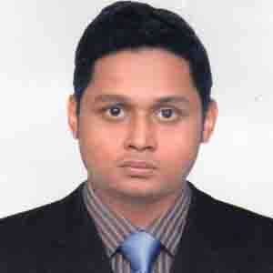

Professional Summary
To work hard with sincerity and integrity and give all efforts to promote the goodwill of the corporation and to acquire organizational goals by proper utilize my education.

- MBA in Finance & Banking, 2018  Leading University, Sylhet  CGPA: 3.94 out of 4.00(Running) | - HSC in Business Studies, 2011  Sylhet Commerce College, Sylhet  GPA: 5.00 out of 5.00
- BBA in Finance & Banking, 2017  Leading University, Sylhet  CGPA: 3.50 out of 4.00 | - SSC in Business Studies, 2009  Rifles Public School, Sylhet  GPA: 4.88 out of 5.00
Academic Qualification

Extra Curricular Activities
- I was the member of Social Service club of Leading University,Sylhet.
- I was the volunteer of the 2nd Convocation Program of Leading University.

Training
- Internship Program at Southeast Bank Limited, Pathantula Branch.
Duration: 3 months (From July 2017 to September 2017)

- Basic Computer Training Course
Duration: 3 months, (From August 2010 to October 2010)

Personal Details
Father’s Name : Babul Kumar Deb
Mother’s Name : Shila Rani Deb
Date of Birth : February 05, 1993
Blood Group : $B^{+}$
Gender : Male
Nationality : Bangladeshi
National ID : 19939196209000172
Marital Status : Unmarried
Religion : Hindu
Permanent Address : Vill:343/1,Uttar Bagbari,Thana:Sadar,PO:Sylhet-3100,Sylhet.

English Proficiency
Reading-High, Writing-High, Speaking-High

Reference

Mohammad Mizanur Rahman Md. Mahbubur Rahaman

Assistant Professor Assistant Professor

Department of English Department of Business Administration

Shahjalal University of Science and Leading University,Sylhet.

Technology,Sylhet. Mobile:01717019305

Mobile:01985263363

Signature
Date: | ____________________  Bulbul Kumar Deb
I do here by declare that above information is true and correctly describes my qualifications and myself to the best of my knowledge.

