Curriculum Vitae

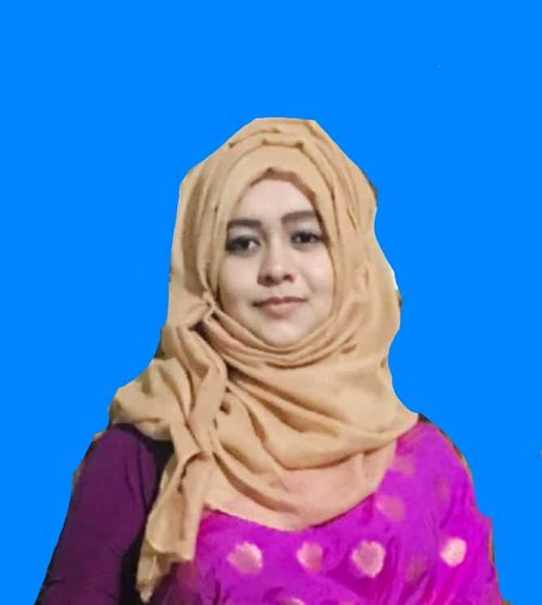
Jannatul Fardous Mousumi
Mob: +8801871546471
E-mail:r.r.nannu90@gmail.com

Career Objective:
To gain practical knowledge and experience and to work in a challenging and competitive environment where strong sense of responsibility and commitment requires, where dignity of work provides job satisfaction and the place of work provides potential avenues for learning and growing and to achieve top-level in the hierarchy of the organization.

Personal Details:

Name : Jannatul Fardous Mousumi
Father’s Name : Jamal Uddin Hasan
Mother’s Name : Momtaz Begum
Permanent Address : Rahman House, Akata-327 North Bagbari, Sylhet.
Mobile : +8801871546471
Date of Birth : 29/01/1995
Nationality : Bangladeshi
Religion : Islam
Sex : Female
Marital Status : Married
Email : r.r.nannu90@gmail.com

Education:

Name of program : Bachelor of Computer Science And Engineering
Department : CSE
Credit Hours : 152
Institute : Leading University, Sylhet.
Result : 3.33 out of 4

Name of Examination : Higher Secondary School Certificate (H.S.C)
Year : 2013
Group : Science
Board : Sylhet
Institute : MC College, Sylhet
Result : 5 out of 5

Name of Examination : Secondary School Certificate (S.S.C)
Year : 2011
Group : Science
Board : Sylhet
Institute : Rifles Public School, Sylhet.
Result : 5 out of 5

Name of Examination :IELTS (Score 6)

Undergraduate Project: Hotel management system.

Language Competency:

Bengali : Excellent in listening, Reading, Writing & Speaking.
English : Good in Listening, Reading, Writing & Speaking.

Computer Skills:

- Operating Systems:  - Windows 7, 8, XP  Internet and E-mail Operations:  - Internet Explorer  - Mozilla Firefox  - Opera  - Google Chrome | - Application Tools:  - Microsoft® Word  - Microsoft® Power Point  - Photoshop
Special Skills:

- Ability to work individually or in a group.
- Leadership and team building capacity.
- Ability to grasp new ideas very easily and quickly under any situations.
- Ability to manage subordinate efficiently.

Experience:
Teaching at different institution>

Interests:

- Photography, , Traveling, listening music, Computer Games.

Signature & Date

………………………………

Jannatul Fardous Mousumi

