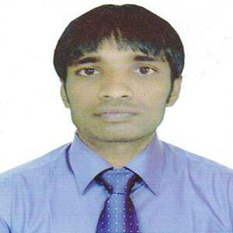
Resume of

ABUL HASEM
Sunarpara, Nobarun /403
Shibgonj,Sylhet
Mobile: 01796-422692
Email : hasanjuri77@gmail.com

Career Objective
To work in challenging and rewarding position to take full advantage of skills.
100% dedication to the institution and improve professional in a positive
environment.
Academic Credentials
M.S.S:
Institute : M.C College,Syhet.
University : National University,Gazipur.
Subject : Economics
Passing Year : 2015
Result : 2.78
B.S.S-Honors’:
Institute : M.C College,Syhet.
University : National University,Gazipur.
Subject : Economics
Session : 2010 to 2011
Passing Year : 2014
Result : 2.88

H.S.C.
Board : Sylhet
Institute : T.N Khanom Degree College
Group : Business Studies
Year : 2010
Grade Point : G.P.A 4.20 in the scale of 5.00

S.S.C.
Board : Madrasah
Institute : Jangiari Dakhil Madrasah
Group : Humanities
Year : 2008
Grade Point : G.P.A 4.75 in the scale of 5.00
Computer Skills

- Course completed on computer from Bangladesh Computer Counci.
- Knowledge about Multimedia Projector class.
Language Efficiency

- Good writing and oral communication ability in language And Bengali.
° Lecturer of ICT in Shahbagh College, Zakigong.
- I was Assistant Teacher in Sylhet Islami Academy, Sylhet.
- Having experience teaching ict subject in 2 renowned Coaching Center.

Personal profile:

Name : Abul Hasem
Father’s Name : Abul Hossen
Mother’s Name : Azifa Begum
Present Address : Sunarpara,nobarun/403,Shibgonj,Sylhet .
Parmanent / Mailling Address: Vill-Jangiari, P.O-Juri,3251
P.S- Juri, Dist- Moulvibazar
Date of birth : 01/01/1991
Religion : Islam
Nationality : Bangladeshi by Birth
National Id No : 19915813547000096
Sex : Male
Marital Status : Unmarried.
Interests : Debating, Encourage other to do well

References

MD.SHAHAB UDDIN
Assistant Professor of Economics Department .
M.C College,Sylhet
Mobile : 01711-976769
Email: shahabuddin82@gmail.com
RAHAT JAHAN
Lecturer of Economics Department.
M.C College,Sylhet
Phone : 01558-493335
E-mail: rahat.jahan19@gmail.com

Declaration

I hereby, declare that the statements made by me in the Curriculum Vitae are true, complete and correct to the best of my knowledge and belief.

(Abul Hasem)

