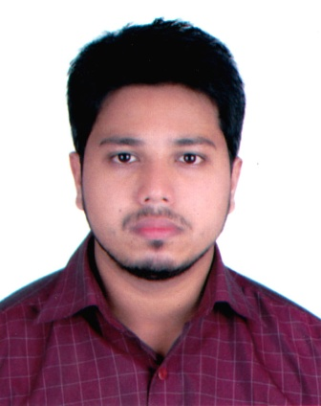

Md. Badrudduza Chowdhury
29/1, Prantik, Shubidbazar, Sylhet-3100
Mobile: +88 01737 292 308
E-mail: b.chy.adil@gmail.com

Objective

To develop a career in a professional and challenging environment that ensures me the best use of my knowledge, skills, efficiency and creativity and where there is an opportunity of self-assessment and improvement through gathering & sharing knowledge.

Academic Standings

Exam Year Institution Concentration CGPA

C.S.E 2016 Metropolitan University BSc. Engr. 3.60
H.S.C 2011 Scholarshome Science 4.80
S.S.C 2009 Blue Bird School & College. Science 5.00

Strength Factors

      - Believe me as an enthusiastic learner.
      - Always have the utmost curiosity to face the challenges and temptation to learn from them.
      - Strong analytical mindset facilitates me to think differently.
      - Can lead and work in a team with absolute Pro-activeness.

Achievement
Maths Olympiad 2008 (Sylhet Dist) - 2nd Runner up.

Language Proficiency

Have the satisfactory level of communication skills and adaptation in terms of Understanding, Speaking and Writing both in English and Bengali.

Computer Literacy

      - Efficient in MS Word, MS Excel, MS PowerPoint & Web Browsing.

Involvements

      - Customer Service Manager- Grameenphone Customer Care, Sylhet.
      - General Secretary of “Flames –An in house musical community of Metropolitan University”
      - Aumni Member, Volunteer for Bangladesh.
      - Branch Manager, UCC Sylhet.
      - Public Relation Officer, Uk-Bangla (ITHM), Sylhet.

Personal Details

Official name : Md. Badrudduza Chowdhury
Father’s Name : Helal Ahmed Chowdhury
Mother’s Name : Humera Begum Chowdhury
Date of Birth : 01-01-1992
Nationality : Bangladeshi
Marital Status : Unmarried
Religion : Islam
Permanent Address : 29/1 Prantik, Subidbazar, Sylhet.

Reference

Shahed Mahmud
FAVP & Branch Manager
Eastern Bank LTD. (Fenchuganj Branch) Cell: 01714 000 732

Declaration

Md. Mohobubul Kadir Chowdhury
SPO & Booth Incharge, One Bank Ltd,
Gutatikor Branch, Sylhet. Cell: 01766 695 463

I am certifying that this résumé correctly describes my biography, education and all other information.

……………………………….
Md. Badrudduza Chowdhury

