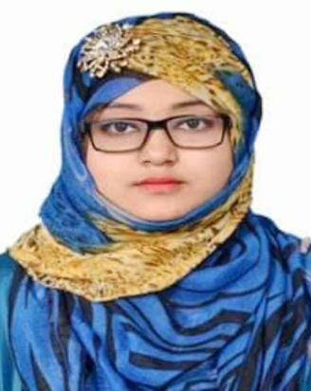
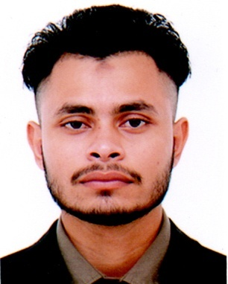

AFROZA AKTER SHEMA
Cell No. +88 01647-863654
E-mail : afroza1993biu@gmail.com

Job Objective:

Looking forward to challenging and rewarding position in the industry by utilizing my Technical and managerial skills to the optimum and growing along with the company

Personal Profile

Father’s Name : Mozammel Hoque
Mother’s Name : Hawa Begum
Nationality : Bangladeshi (by birth)
Languages Known : Bengali as mother tongue & English as second language
Religion : Islam
Sex : Female
Date of Birth : 02 Oct, 1993
Marital Status : Unmarried
Height : 5’-2” (feet-Inch)
Weight : 54 Kg
Blood Group : “A” +Ve (Positive)
Present Address : Asia Mansion,Ward No -25,Muminkhola ,South Surma,Sylhet
Permanent Address : Sarulia-1361,Thana-Demra,Dist-Dhaka,Bangladesh

Academic Education

Master of Business Administration(MBA)
Concentration : Finance (FIN)
Bangladesh Islami University.
Dhaka Bangladesh.
CGPA: 3.73 (out of 4.00)
Passed in 2018

Bachelor of Business Administration(BBA)
Concentration: Finance (FIN)
Bangladesh Islami University.
Dhaka Bangladesh.
CGPA: 3.65 (out of 4.00)
Passed In 2017

Higher Secondary Certificate (HSC)
Group: Business Studies
Govt. Adamjeenagar M.W College, Narayangonj.
Dhaka, Bangladesh
GPA: 3.50 (out of 5.00).
Passed In 2012 under Dhaka Board

Secondary School Certificate (SSC)
Group: Science
M . A Sattar High School.
Dhaka, Bangladesh
GPA: 3.75 (out of 5.00)
Passed in 2010 under Dhaka Board

Job Experience
. 1 Year Experience in Touhida Diagnostic Hospital as Executive Officer (part time)
. 10 Months Experience in Arcadia International English Medium School (running)
. 4 months Experience in Exim Bank(Internship)

Relevant Skills
( Afroza akter Shema )
Language Skills  Interpersonal skills  Technical skills | Conversant in English and Bengali  Comfortable in communicating with people of every level, motivation and leadership skills.  Proficient in Microsoft Word, Excel, and PowerPoint, Efficient in Internet browsing & searching

Interest & Hobby

Interest in reading books & newspaper,listening to music and traveling.

Reference

2. Zulfiqar Hasan

Associate Professor (Finance)

Bangladesh Islami University
Cell Phone: 01712546825
E-mail: hasanzulfiqar@yahoo.com

1. Ayesha Saimoon
Assistant Professor
(Finance & Banking)
Bangladesh Islami University
Cell Phone: 01726427878
E-mail: ayeshasaimoon@yahoo.com

…………….
Signature
Date:

