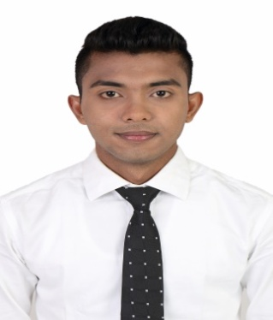
CURRICULUM VITAE
OF
ALI IMRAN MONIR
106/9, Jalalabad Cantonment, Sylhet
Mob: +8801738385029, E-mail: monerhossain379@gmail.com
Career Objective:
I am enthusiastic, ambitious, dynamic eager to meet challenges to work for maximize the satisfaction of passengers with utilizing exceptional customer service and hospitality skills.
SPECIAL TRAINNING:
I have completed a two months long special training on basic flight service from jobsA1.com
ACADEMIC BACKGROUND:
Degree
MC College, Sylhet
HSC 2014-2015
Sylhet United Model College , Sylhet
SSC 2011-2012
HazratShahjalal High School, Sylhet
PERSIONAL DETAILS:
Father’s name: Jashim Uddin
Mother’s name: Shapna Begum
Permanent Address: 106/9 Jalalabad cantonment, Sylhet
Date of Birth: 10-01-1997
SWIMMING:
I’m very good in swimming.

INTERESTS:
Travelling, Reading Books, Swimming, Cricket, Badminton, target shooting, Photography, Listening music, Watching news.
OTHER SKILLS:
Bangla- Mother tongue English- Fluent both in speaking and writing.
Computer literacy: Ms. Office, Ms. Word, Ms. Excel, Ms. Power point, Internet Browsing.

