Resume
of
AMINUL ISLAM

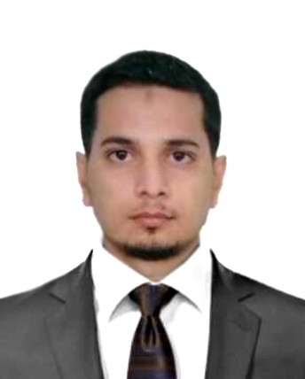

9/C Mowchak Shadipur, Shibgonj Sylhet.
Contact No: +8801733546120
E-mail: aminulislam.ai66@gmail.com

CAREER OBJECTIVE

“To face challenges using knowledge, perception, and innovation to pursue a long-term successful career in a dynamic and professional environment of any organization through own attitude, hard work, dedication, and determination.”

EDUCATIONAL PURSUITS

Program  Major  Result  Department  Passing Year  University  Institution Name  Program  Major  Result  Department  Passing Year  University  Institution Name  Examination  Result  Passing Year  Discipline  Institution Name  Board  Examination  Result  Passing Year  Discipline  Institution Name  Board | : Master’s of Social Science (M.S.S)  : Sociology  : Running  : Department of Sociology  : 2016  : National University  : M.C. College, Sylhet.  : Bachelor of Social Science (B.S.S)  : Sociology  : CGPA-3.05 (Out of 4.00)  : Department of Sociology  : 2015  : National University  : M.C. College, Sylhet.  : Higher Secondary Certificate (H.S.C)  : GPA- 4.50 (Out of 5.00)  : 2011  : Humanities  : Sylhet Govt. College, Sylhet.  : Sylhet.  : Secondary School Certificate (S.S.C)  : GPA- 4.38 (Out of 5.00)  : 2009  : Humanities  : Syed Hatim Ali High School, Sylhet.  : Sylhet.

COMPUTER PURSUITS

Application Package: MS Office Package (Word, Excel, PowerPoint, Access)

Knowledge about: I have excellent typing speed in English & Bangla. I have proficiency in
Internet Browsing. And I am certified from Bangladesh Computer Council in Basic Computer Course. I have one year experience in Social Media Marketing (SMM) site.

Operating Systems: Windows 7,8, XP, Mac, etc.

LANGUAGE SKILLS

Name | Writing | Reading | Listening
Bangla | Excellent | Excellent | Excellent
English | Excellent | Excellent | Excellent

ACHIEVEMENTS

I got first prize in 100-meter sprints in annual sports at M.C College (2013).
I had played in Mayor Cup Football Tournament (2011-12).
I was a member of a renowned literature organization names ‘KOBITA PARISHAD’ at M.C College, Sylhet.

PERSONAL DETAILS

Name  Father’s Name  Mother’s Name  Permanent Address  Date of Birth  Nationality  Religion  Sex  Marital Status  Blood Group | :Aminul Islam  :Abdul Goffar  :Khaleda Begum  :9/C Mowchak Shadipur,Shibgonj Sylhet  :17th March 1993  :Bangladeshi (By Birth)  :Muslim  : Male  :Single  : O+

REFERENCES

PANNA RANIROY ABU SAEED EMON
Head & Associate Professor 2nd Manager
Dept. of Sociology Shahjalal Islami Bank Limited.

M.C. College, Sylhet. Dopadigirpar, Bondorbazar, Sylhet.

Mobile No. +8801712125011 Mobile No. 01911279883

I do hereby ensure that the above all information is true to my best knowledge.

______________
Aminul Islam

