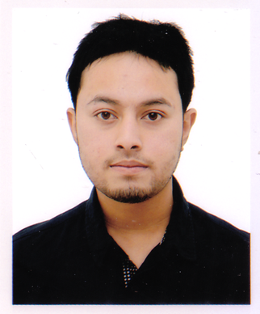
Curriculum vitae
MD. ABUL KAWSER RIPON

Mailing Address
Address:
BoroiKandi, Sunampur, Sylhet Main Post Office, Dakshin Surma,
Sylhet-3100, Bangladesh
+8801746137540

Career Objective
To obtain a challenging position in any area of Business that will provide future
opportunities for growth and development and to use my skills and experience that I have
acquired in my education life and to dedicate my whole effort to achieve the
organizational goal.

Personal Details
Name : MD.Abul Kawser Ripon
Father’s Name : MD. Abul Hossain
Mother’s Name : Rokea Begum
Present Address : BoroiKandi, Sunampur, Sylhet
Date of Birth : 08/09/1992
Marital Status : Unmarried
Gender : Male
Religion : Islam
NID No :509 296 1134
Nationality : Bangladeshi (by birth)
Blood group : B (Positive)

Academic Qualifications
- Bachelor of Business Administration (BBA)
Institution : Royal University Of Dhaka, Dhaka,Bangladesh
Year : 2016
Subject : BBA (HRM)
Result : CGPA: 3.50 (On Scale of 4.00)
- Higher Secondary Certificate (HSC)
Institution : Madan Mohan College, Sylhet, Bangladesh
Passing Year : 2011
Board : Sylhet
Result : GPA: 3.30 (On Scale of 5.00)
Group : Science

- Secondary School Certificate (SSC)
Institution : The Aided High School, Sylhet, Bangladesh
Passing Year : 2009
Board : Sylhet
Result : GPA: 4.94 (On Scale of 5.00)
Group : Science

Language Proficiency

Excellent in Speaking, Reading, Writing and Listening both in English and Bangla.

Computer Literacy
Operating System : Windows 7, 2000, XP.
Application software : MS Word, Excel, Power Point.
Additional Skill : Internet Browsing.
Experience of Computer : Having a Certificate on Computer Course.

Hobbies
Traveling, Reading Story Books, Playing, Knowing Nature etc.

Experience
- Member of Royal University Of Dhaka Social Welfare Club
- Have been worked as a BP of ‘OBHAI’
- Have been worked as a akij computer besic computer Teacher .

Self Assessment
- Strong desires for leading an honest life with dignity.
- Aspiration to build a career showing superior performance.
- Energetic, Sincere, Hard working, Honest and Dutiful.
- Able to work at any time at any place.
References
Anukul Kumar Nag Md. Kamruzzaman
Deputi diroctor Manager, Burzan tea Estates Ltd
Bngladesh Bank, Sylhet Khadimnagar-3103
Phon. 01741884921 Phon : 01917197627
E-mail: anukulnag78@hotmail.com

Declaration
I would be appreciated if you give me an opportunity to work with you and to execute
myself with your support. All the information provided here are correct and complete.
Yours Sincerely,

.........................................
Signature of Applicant

