CURRICULUM VITAE
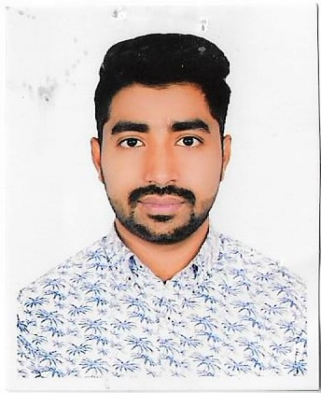

Name : Md Akash
Address : House-18, Line No.1, Road 4,
Mirpur 11. Dhaka 1216
Mobile No: +8801681161197
E-mail: akashahammed705@gmail.com

Career Objective:
- To continue my career with an organization that will utilize my supervision & administrative skills to benefit mutual growth and success.
Educational Qualifications:

Degree | Institution/College/  School | Board/  University | Subject/  Group | Passing  Year | Result
B.B.A | Mirpur University College | National  University | Marketing | 2019 | CGPA  2.56
H.S.C | Mirpur University College | Dhaka | Business studies | 2013 | GPA  3.00
S.S.C | Chiriakhana Botanical High School | Dhaka | Business studies | 2011 | GPA  3.44

Language Proficiency:
- English : Well versed in both written & spoken English.
- Bengali : Mother tongue.

Computer Skill : Ms.Word, Ms.Excel, PowerPoint, Internet browsing.

Experience : Worked at Westeen Fashion House Position as Branch Manager. Also Works Pizza Roma Position as Floor In charge .

Personal Data:

Full Name : Md Akash
Father’s Name : Md. Jamil Hossaion
Mother’s Name : Shamma Perveen
Number of Siblings : 1
Date of Birth : 20-May-1996
Nationality : Bangladeshi
Religion : Islam
Gender : Male
Marital Status : Unmarried

Present Address : House-18, Line No.1, Road 4, Mirpur 11. Dhaka 1216

Permanent Address : House-18, Line No.1, Road 4, Mirpur 11. Dhaka 1216

________________________
(Md Akash )

