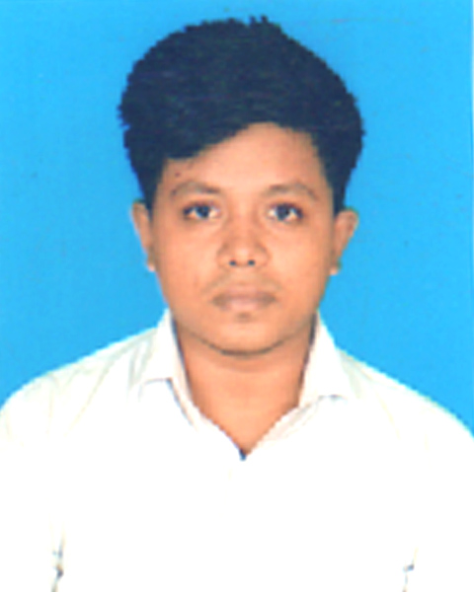

CURRICULUM VITAE
OF
MD ABDUL KADER AKASH
Present Address: East Barandi Mollapara,
Post: Jashore-7400, Thana: Kotwali,
District:Jashore.
Mobile : +8801929-877218
EMAIL : maxmy534@gmail.com

Career Objective :

To pursue a work by which I can serve by using my vision, positive attitude, interpersonal relationship, communication skill to take the challenges that will also ensure me the opportunity to grow by learning new skills and knowledge as well as develop your organization.

Educational Qualification

Bachelor Of Business Administrative (B.B.A):

Institution Name : Cantonment College, Jessore
Group : Accounting
Result : Not Published Yet
Board : National University

Higher Secondary Certificate (H.S.C):

Institution Name : Dr. Abdur Razzak College, Jessore
Group : Business Studies
Result : GPA – 3.59 (out of 5.00)
Passing Year : 2015
Board : Jessore

Secondary School Certificate (S.S.C):

Institution Name : Municipal Priparatory School, Jessore
Group : Business Studies
Result : GPA – 3.95 (out of 5.00)
Passing Year : 2013
Board : Jessore
Language Proficiency

Bengali (Excellent in Reading, Writing & Speaking)
English (Good in Reading, Writing & Speaking)
Computer Skills:

Office Suite : MS Word ,Web-design & Development
Internet : Using Internet, Browsing, Downloading Etc
Personal Strengths

- Industrious.
- Excellent Communication capacity.
- Motivating, Leading & Convincing power.
- Helping mentality & realistic.
- Like serving people.

Personal Information

Name : Md: Abdul Kader Akash
Father’s Name : Md: Yasin Babu
Mother’s Name : Mst: Nargis Begum
Date of Birth : 5th May 1998
Nationality : Bangladeshi (By Birth)
Religion : Islam
Gender : Male
Marital Status : Single
Birth Registration No. : 19984124716109181
Blood Group : O+
Height : 5 Feet 4 Inch
Permanent Address : East Barandi Mollapara, Post: Jessore-7400, Thana: Kotwali,
District: Jessore.

Confidence

I am a self-starter, strong inter-personal skill with an ability to work at a high pace on one’s own imitative under pressure, I am undersigned, hereby declare that I will be responsible for any wrong information provided here.
Declarations:

I am Md: Abdul Kader Akash certify that to the best of my knowledge and belief, these data correctly describe my qualification.

Signature

Md Abdul Kader Akash

Date:

