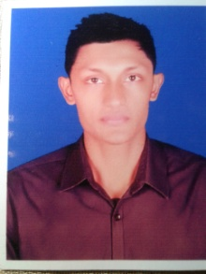
Akbar Ali
Address: Sylhet Bangladesh
Contact: +8801776494578
E-mail: Akbarbd65@gmail.com

`Objective:

I am an enterprising young professional intending to continue my development as a consultant. I think in terms of results and objectives, I am enthusiastic, and work with decisiveness and conviction. I have a proactive attitude and find positive ways to stimulate and engage with people.

Personal Information
Name Akbar Ali
Father‘s Name Kalu Miah
Mother`s Name Rahima Begum
Date of Birth 05/01/1998
Religion Islam
Nationality Bangladesh

Education Qualification
B.S.S : From university of Balagonj Degree Collage
Intermediate : From Balagonj Degree Collage in the year 2016
Languages
English, Bangle

