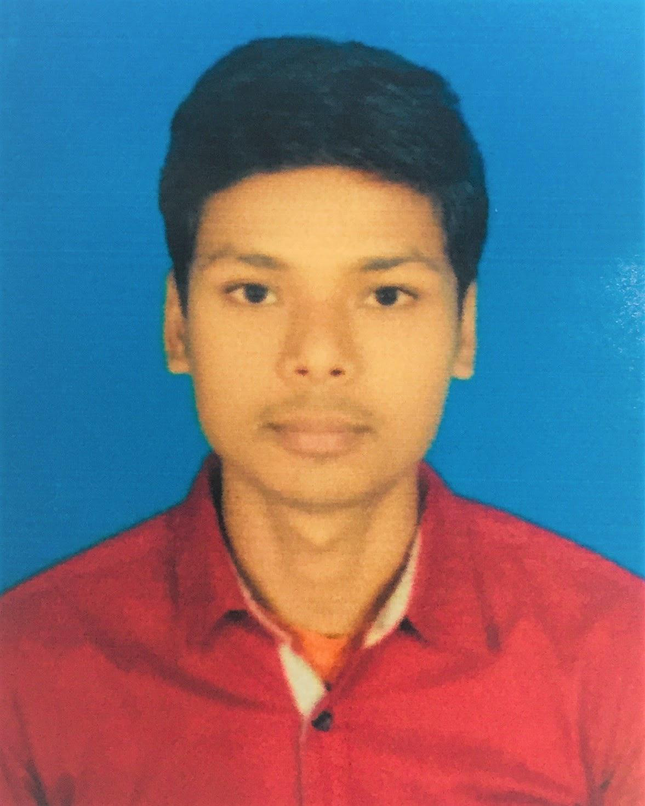
RESUME
OF
Md. AL-AMIN
House :14/1 Unit-A,Road :03,
Bank Town, Savar, Dhaka.
Email :alaminxiolancer@gmail.com
Mobile:+8801983-858192

Career Objective:

To work an organization using my knowledge, experience and my ability to achieve best results and to add value to my post with my initiative ideas. My ultimate aim in to work as an active member of an energetic team in a large environment so that I can expose my full potency.

Personal Information:

Full Name : Md. Al-Amin
Father’s Name : Md. Abul Hossain
Mother’s Name : Selina Begum
Permanent address : Vill: Digholdangi, P.O.: Beracuthy
P.S.: Nilphamari, Dist.: Nilphamari

Mailing Address :C/o- Md. Obaidur Rahman Liton
14/1, Ground Floor, Bank Town,Savar, Dhaka

Nationality : Bangladeshi (By Birth)
Religion : Islam (Sunni)
Date of Birth : 28 September 1996
Marital Status : Single
Sex : Male
Birth Registration : 19967316482001066
Height : 5-7”
Weight : 60 Kg
Blood Group : B+ve

Computer Knowledge:

Operating System : Window-XP, 7, 8 & 10
MS Office Program : MS-Word, MS-Excel, MS-PowerPoint, MS-Access
E-mail & Internet : Full Skill

Educational Background:

Degree : Bechelor Of Social Science (B.S.S)
University : National University
Institution : Dinajpur Govt. College
Discipline : Humanities
Result : Higher 2st Class
Passing Year : 2019.
Board : Dinajpur

Degree : Higher Secondary Certificate (H.S.C)
Institution :Khalisha Belpukur School & College.
Discipline:Humanities
Roll : 366589
Result : GPA-2.75 ( Out of 5.00)
Passing Year : 2015.
Board : Dinajpur

Degree : Secondary School Certificate (S.S.C)
Institution : Botlagari High School
Discipline : Humanities
Roll : 572586
Result : GPA-3.19 ( Out of 5.00)
Passing Year : 2013
Board : Dinajpur

Language Proficiency:

Excellent verbal and written communication skill both in Bangla and English.

Computer Literacy:

Have successfully completed the Three (3) month course on “Office Programme” from the computer Training Center of Sheikh Hasina National Youth Center. Savar in the session October’ 2019 to December’2019.

Working Experience:

Now I’m working in XioSoft,(www.xiosoft.xyz.com) Saidpur, Nilphamari as a ‘Computer Operator & Customer Support’ since : 01-06-2020 to till now.

Personal Abilities:

- Ability to learn quickly
- Good interpersonal skill.
- Hard working, Energetic and dynamic.
- Good Team member.
- Adaptive and flexible
- Well-groomed & possesses amiable personality
- Analytical bent of mind.
- Helpful minded.

Interest:

Traveling, Internet surfing, Reading, listening music & playing Cricket.

Certification:

I, undersigned, certify that to the best of my knowledge and belief this resume correctly describes my qualifications and me. Any Willful misstatement descried here in may lead to my disqualification or dismissal, if employed.


Signature

( Al-Amin)

