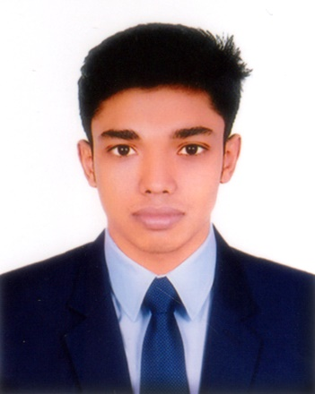
CURRICULUM VITAE
MUSLIM ALAM

House: 07, Road: 15, Sector: 12, Uttara, Dhaka- 1230.
Mobile: 01953-370150
e-mail: muslimalamtutul0311@gmail.com

OBJECTIVES:
To obtain a position of responsibilities that utilizes my skills, experiences and keens to work in an environment, where I can enrich my knowledge & develop organization.

EDUCATIONAL BACKGROUND:

Secondary School Certificate
Board : Dhaka
Institution : Shanto-Mariam Academy Of Creative Technology, Dhaka
Group : Science
Result : 4.14 (Out of 5.00)
Passing Year : 2019

Higher Secondary School Certificate
Board : Dhaka
Institution : Siraj Uddin Sarker Model School & College
Group : Business Management
Result : Running

COMPUTER LITERACY:
Familiar with operating system windows 7, 8, 10
Adequate Knowledge about MS. Word, MS. Excel & Internet.

COMMUNICATION SKILL:
Natively proficient in English (Spoken, Reading &Writing) Proficient in Bengali

WORKING EXPERIENCE:

- Company Name : Shanto-Mariam University of Creative Technology
Location : Uttara

Designation : Pion (4 Years)

PERSONAL INFORMATION

Name : Muslim Alam
Father’s Name : Md. Mazid Sheikh
Mother’s Name : Riziya Khatun
Marital Status : Unmarried
Date of Birth : 31 December, 2001
Permanent address : Village # Rupdia Road, P.O- Rupdia.
P.S- Sadar, Dist- Jessore.
Present address : House: 07, Road: 15, Sector: 12,
Uttara, Dhaka- 1230.
Nationality : Bangladeshi (By Birth)
Height : 5.5"
Weight : 52 Kgs
Blood Group : A (+)

DECLARATION:

I hereby declare that the above furnished details are true and correct to the best of my knowledge.

Signature & Date:
(Muslim Alam)

