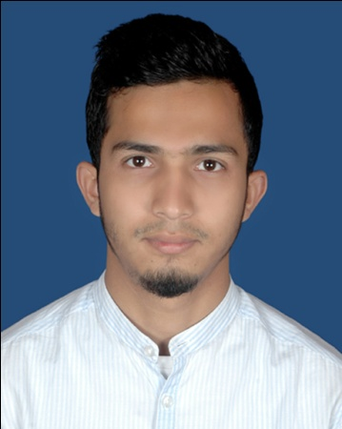
Md. Albab Ahmed Khan
Rangdhonu-101/2, West Chowkidekhi, Sylhet-3100
Mobile: (+088) 01785046155 | Email: albabphy@gmail.com
facebook.com/albab.ahmedkhan

About Me

To get a Challenging position where I can express my ideas and thinking with free mind and full liberty.

 | Experience
Teacher & Admin  Pencil Coaching Center  2017 – Present |  | Teacher  Surjodoy Atim School  2016 – 2018

Education

BSC
National University of Bangladesh
Session: 2013-14
Department of Physics (4th Year)
CGPA: Appearing

HSC
Sylhet Govt. College, Sylhet
Session: 2011-12, Board: Sylhet
Group: Science
GPA: 4.20
SSC
The Aided High School, Sylhet
Session: 2009-10, Board: Sylhet
Group: Science
GPA: 5.00

Other Skills
- Basic knowledge about Computer.
- Basic knowledge about internet & web browsing.
- Microsoft Word & Excel.

Language

Bangla

English

Personal Profile

- Father’s Name : Md. Babul Miah Khan
- Mother’s Name : Aysha Begum
- Date of Birth : 01 September 1995
- Nationality : Bangladeshi
- Religion : Islam
- Marital Status : Unmarried
- Blood Group : O(+)ve
- Height : 5’5”

Reference

Dr. Muhammad Alauddin Khan
Associate Professor, Department of Physics
M. C. College, Sylhet

Khan Muhammad Abdullah Al Mamun
Editor, Monthly Shopno Ghuri.
Director, Ark Real Estate Pvt. Ltd.

Signature with Date

