Mailing Address:
Call phone: +8801798207182
E-mail: mostafizurnaim465@gmail.com

RESUME
OF
MD. MOSTAFIZUR RAHMAN

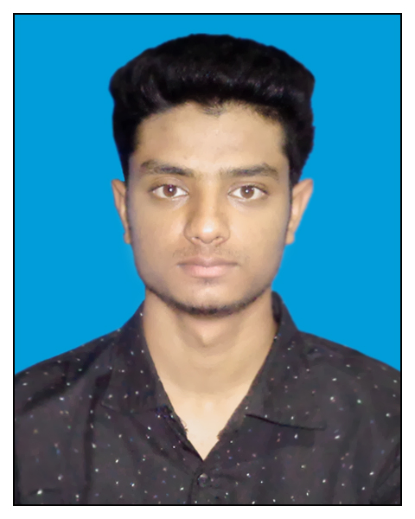

Career Objectives

To pursue a challenging career in a Organization where I can devote my full effort to
achieve the goal of the company, to take the job with a great sense of responsible, to enjoy the challenge of new situation and to be expert to make a positive contribution to the position.

Academic Qualification:
Diploma in Textile Engineering
- Institute : City polytechnic & Textile Institute, Rajshahi.
- Group :Textile
- Passing Year : 2018
- Result : 3.43 (out of 4)
- Board : Technical Education Board, Dhaka.

Secondary School Certificate (S.S.C)
- Institute : Baghoil School & College
- Group : Business Studies
- Passing Year : 2014
- Result : 3.94 (out of 5)
- Board : Rajshahi

Industrial Engineer

Experience:
∗Worked in a Gmts Industries named “Orchid styes ltd.” as a JR .Executive. for Eight (08) months (04.feb.2018)
∗Worked in a Gmts Industries named “Jic suit ltd. ” as a Assistant(I.E) for Two (02) months (03.nov.2018)
Duties/Responsibility
- Skill test
- Capacity study
- Method study
- Production study
- Improve production
- NPT (Non Productive Time) report
- Line balancing
- Time study
Computer Skills:
- Microsoft Office (Word, , Excel, )
- Having Good Knowledge of Software.
- Having Good Knowledge of Internet.

Language Efficiency:
Bengali : Mother Tongue.
English : Reading, Writing, Listening fluently and well in speaking.

Personal profile
Full Name : Md. Mostafizur Rahman
Father’s Name : Md. Mahabul Alom
Mother’s Name : Mst. Nargis Khatun
Date of Birth : 12th October 1997
Marital status : Unmarried.
Blood Group : O+ (Positive)
Permanent Address : Vill.- Notun Ruppur, Post.- Pakshi, Tana- Ishwardi, Dist.- Pabna.

Declaration
I hereby, declare that the statements made by me in the curriculum vitae are true, complete and correct to the best of my knowledge and behalf.
Reference:
MD. NAHID KHAN. MD.LATIF AHAMMED
Designation: Manager Designation: IE Executive
Dept: IE& Planning Dept: IE
Jic suit ltd BEXIMCO APPAREL LTD

--------------------------------
Md. Mostafizur Rahman
Date:

