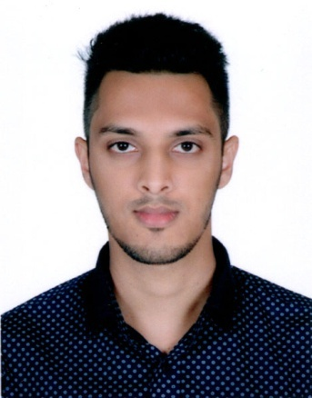
Curriculum Vitae
Of
Ali Ahemd Ripon

Address: 15/1, North Pirmoholla, Paharika, Sylhet.
Mobile: 01733721316
E-mail: ripom6162@gmail.com

Career Objective:
I am a highly energetic and motivated individual wishing to use academic and practical knowledge to pursue a long career path in social institution having the intention to work with sincerity, honesty and to face challenges of time to contribute to the nation and economy.
Academic Background:
Name of Exam | Board/University | Group/Subject | Division/Class/GPA | Passing Year
B.B.A | Metropolitan University, Sylhet | Business Studies | Running | 2019
H.S.C | Sylhet Commerce College | Commerce | 4.20 | 2014
S.S.C | Pachim Sadar High School | Science | 4.63 | 2012

Language Proficiency:
Language | Speaking | Reading | Writing
Bengali | Well | Well | Well
English | Medium | Well | Medium

Computer Skill: Micro Soft Office Application, Adobe Photoshop, Adobe Illustrator and Internet Browsing.
Interest: Travelling, Internet Browsing, Playing Cricket
Experience:1 Year work Experience signature media ukas a photo retoucher.
Personal Information:
Father's Name | : Md. Shamsul Islam
Mother's Name | : Dilara Begum
Permanent Address | : 15/1, North Pirmoholla, Paharika, Sylhet.
Date of Birth | : 04th April 1994
Marital Status | : Single
Gender | : Male
Nationality | : Bangladeshi by birth
Religion | : Islam
Contact Number | : 01733721316
E-mail Address | : ripom6162@gmail.com

Name of Referees:  Dr. Mohammad Jamal Uddin  Associate Professor & MBA Coordinator  Department of Business Administration  Metropolitan University  Alhamra,Zindabazar, Sylhet  01571733803  muddin@metrouni.edu.bd | MD. Rafiqul Islam  Sr. Lecturer  Department of Business Administration  Metropolitan University  Alhamra, Zindabazar, Sylhet  01625853231  rafiqul@metrouni.edu.bd

Ali Ahmed Ripon

