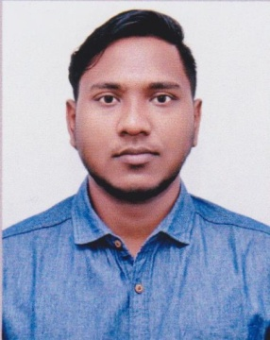
01779-193293©
theanik93@gmail. com
Nayasharak,Al-Helal 50/A
P.O:Sodor-3100,Dist:Sylhet.

Onik Das
Experience
Manager
Bornali Jewelers , Sylhet
From January 2016 to November 2016.

Telemarketing Executive
A&T Consultancy
From March 2017- November 2018

Education

Higher Secondary Certificate.
Board: Sylhet
Group: Science
Result : Grade- “A-”
GPA-3.50
Year of Passing: 2013
Sylhet Science College, Sylhet

Secondary School Certificate.
Board: Sylhet
Group: Science
Result : Grade- “A”
GPA-4.63
Year of Passing: 2010
The Aided High School, Sylhet
Skills

- Computer(MSWord,MSExcel,MSAccess,MSPowerpoint,Email&InternetBrowsing)
- Language(Bengali&English&Hindi)
- Able to engage and speak to customers.
- Customer service experience in a retail environment.
PersonalInformation

Father'sName Mother'sNameDateofbirth
MaritalStatusReligion
: Babul Das
: Radha Rani Das
: 31st August 1995
:Unmarried
: Hinduism
PermanentAddress :Nayasharak,Al-Helal 50/A,P.O:Sodor-3100,Dist:Sylhet.

