2017

Curriculum Vitae Of Sojib ray
PERMANENT ADDRESS: NILOY-33 R/A, NOTUNPARA, SADAR, SUNAMGANJ-3000.
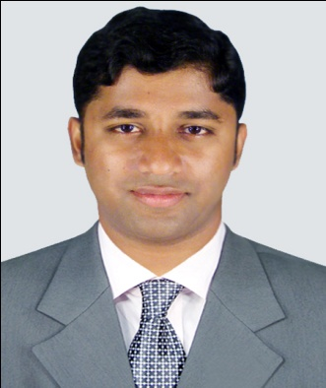

MAILING ADDRESS
CONTACT ADDRESS

Sojib Ray

C/O.Somorendra Ray
Niloy-33 R/A, Notunpara
Sunamganj- 3000, Bangladesh
Mobile no. -+8801710341406
Email-sojibray007@gmail.com
……………………………………………………………………………………….
I believe in quality and service. I would like to provide better service in time and cost effective way for maximizing customer satisfaction and employees gain. I would like to attain the goal through continuous process and self-improvement.

ACADEMIC QUALIFICATION

- Bachelor of Science (B.Sc.)
Passing Year : 2013 Department: Computer Science And Engineering
Session : 2008-2009
Result : CGPA 2.93
Institution : Leading University, Sylhet. (Approved By UGC)

- Higher Secondary School Certificate (H.S.C.)
Passing Year : 2007 (Session:2005-2006) Group: Science
Result : GPA-3.60
Institution : Sunamganj Govt.College, Sunamganj. (Under Sylhet Board)

- Secondary School Certificate (S.S.C.)
Passing Year : 2005 (Session: 2003-2004) Group: Science
Result : GPA-4.25
Institution : Govt. Jubilee High School, Sunamganj (Under Sylhet Board)

PROFESSIONAL COURESE

• Course On Oracle 11g DBA.

COMUNICATION SKILL

Bangla is the first language. Proficiency in written and spoken English is good as the second language.
COMPUTER SKILL

Operating System : Microsoft Windows XP Professional & Microsoft
Windows7/8/10.
Application Software : MS Word, MS Excel, MS Power point & Internet
Browsing, Email Processing etc.
KEY COMPETENCIES AND SKILLS

Web Development
•Knowledge of HTML, CSS, Bootstrap, Wordpress, Plugins installation and JavaScript/jQuery
•Awareness of the Web Development industry, and new technologies.
•Social Media Monetization Strategies
•Writing up technical manuals and user instructions.
•Strategically thinking through all parts of the design process
•Knowledge of international web standards and protocols

PERSONAL SKILLS

Creative thinker
Imaginative
Energetic
Deadline led
Initiative
Attention to detail
Innovative
Problem solving
Reliable
Team player
Analytical

PERSONAL DETAILS

Name : Sojib Ray
Father’s Name : Somorendra Ray
Mother’s Name : Biva Ray
Date of Birth : 15th January, 1990.
Marital Status : Unmarried
Religion : Hindu
Nationality : Bangladeshi
Blood Group : O+
National ID No : 19909028905000038
Present Address : Niloy-33, Notun Para, Sunamganj-3000.
Permanent Address: Niloy-33, Notun Para, Sunamganj-3000.

CERTIFICATION

I, the undersigned certify that to the best of my knowledge and belief, the above stated data correctly describes my qualifications, my experience and me.

Sincerely yours,

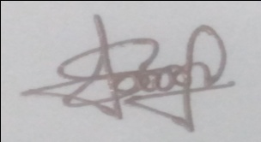
_______________
Sojib Ray
Date:15-09-2017

REFERENCES
Rumel M S Pir  Assistant Professor,  Department of Computer Science & Engineering,  Leading University,Sylhet.  Mob- 01758228736  Email – rumel902@hotmail.com | Aiyub Bokth Joglul  Mayor,  Sunamganj Pourashava,  Sunamganj.  Mob-01712324900  Email:sunampoura@yahoo.com

