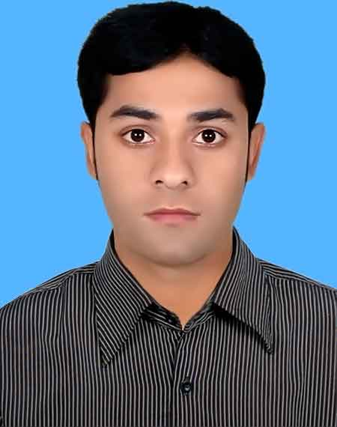
Md. Arifur Rahman
Diploma in Civil Engineering
Village: Notun Pechakola
Upzila. Bera
District:Pabna
Cell: 01634201047
Email: rarifur830@gmail.com

Objective:
Looking for hard, challenging and interesting job where I will have the scope to utilize my potentiality, adaptability and skill to do something innovative and from where I will be able to enhance my knowledge.
Educational qualification:
- Diploma in engineering
Passing Year: 2016
Department: Civil Technology
GPA-3.82(out of 4)
Pabna Polytechnic Institute, Pabna.
Board: BTEB.

- Secondary School Certificate (SSC)
Passing Year: 2012
Group: Science
GPA-5(out of 5)
Board: Rajshahi
Nakalia Sarasia Banik High School

- Basic Trade Auto CAD (360 hours)
Passing Year :2016( January to june)
Trade: Auto CAD
Result: A+

- Industrial Training
- Comprehensive Holding and Development Limited (CHDL)
Result: A+

Personal skills:
- Ability to cope up with different situation.
- Very good temperament and enjoy challenges.
- Co-operative, Innovative & hardworking.
- Organizing & leadership competence.
- Good communication skills and a very good team player.
Computer skills:
- Operating System: Windows 7/8/10.
- Office Programs: Microsoft Office/ Excel
- Auto-CAD (2D&3D).

Language proficiency:
- Bengali (Native)
- English (Both Verbal & writing)

Personal information:

Name : Md. Arifur Rahman
Father's Name : Md. Harunar-Rashid
Mother's Name :Most.Fulpori Khatun
Date of Birth : 15/04/1997

Permanent Address : Village:Notun Pechakola.
Thana:Bera,Dist:Pabna
Sex : Male
Marital Status : Unmarried
Religion : Islam
Nationality : Bangladeshi (by Birth)
Blood Group : B+
Height : 5’4”
Experience : I have 6 month experience of working at Dalia Builders ltd. and 1 year experience of working under a contructor.
Designation: Site Engineer.

Job location: Savar

References:

Engineer Md.Motahar Hossain
Instructor of CivilTechnology
Pabna Polytechnic Institute, Pabna.
Mobile: 01711-578671

Proclamation:

I hereby declared that the information given above is correct.

Md. Arifur Rahman

