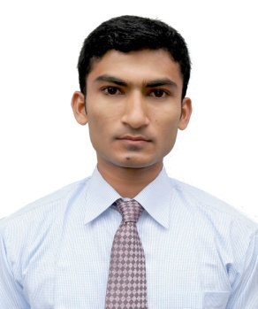
MD. ARIFUR RAHMAN
Rangpur, Bangladesh.
Mob: +8801737501081
E-mail: armilon2003@gmail.com

CARRIAR OBJECT
I am seeking employment with a company where I can use my talent and skills to grow and expand the company. I want to be part of the success in an environment and growth and excellence.

PROFESSIONAL SKILL
    - I am able to show creativity my work.
    - I have knowledge about software and hardware.
    - I have a good communication power.
    - Coordinate the repair and maintenance of office supplies.
    - Successfully implemented innovative scheduling system to more efficiently.
    - Maintained a sufficient record of office supplies.
    - I am punctual at my work.

EDUCATION QUALIFICATION

Qualification | Year | Concentration/Major | Institute | Board/  University | CGPA/%/  Achievements
B.S.S. Honor’s | 2015 | Economics | Carmichael College Rangpur. | National University | 3.03 out of 4.00
HSC | 2011 | Science | Sunflower School & College. | Dinajpur | 3.90 out of  5.00
SSC | 2009 | Science | Kaya Golahat High School & College. | Dinajpur | 4.00 out of  5.00

TRAINING UNDER LICT PROJECT (BCC)
Training | Batch details | Specialization/track | From | To
Foundation Skills | FS-CCR-20-SE | Smart Executive | 16- Apr-17 | 30-Sep-17

COMPUTER SKILL
Microsoft Word | Email
Microsoft Excel | Modern Social media
Microsoft Power point | Computer Fundamentals

PERSONAL ABILITY

Energetic, innovation hard working
- Leadership skill and working capability in group and individual working condition
- Ability to communicate with other people freely
- Able to work user stress & work under team
- Taking initiating to solve problem and like to lead from the front
- Respect the other’s decision and comment
- Communicative, Friendly, Enthusiastic, Self-motivated, Industrious and punctual.

PERSONAL PROFILE
Name : Md. Arifur Rahman
Father’s Name : Md. Abdul Latif
Mother’s Name : Morsheda Begum
Date of Birth : 08 August,1994
Present Address : College Para, V.I.P Road, Sadar, Rangpur , Bangladesh
Permanent Address : Vill: South Sonakhuli (Talipara), PO: Sonakhuli
PS: Saidpur, Dist: Nilphamari
Marital status : Unmarried
Nationality : Bangladeshi
Religion : Islam
Sex : Male
Blood group : O+
Height : 5’-8”
National Id Number : 19947318527000426
Contract Number : +8801737-501081
Email : armilon2003@gmail.com

LANGUAGE PROFICIENCY
- Bengali: Mother tongue.
- English: Fluent Speaker and Writer in English.
HOBBIES AND PASTIME
Travelling, Tree Plantation, Catching Fish, Swimming, Watching Movies, Enjoy Attending Seminars, Also Interested in Any Religious Work.

REFERENCE
Razia Sultana Rimi
Business Development Executive
Far-East IT Solutions Limited
+8801712901015
E-mail: razia6934@gmail.com

DECLRATION: I, hereby declare to the best my knowledge and belief that this cv correctly describe my qualification, experience and abilities. I realize that willful misstatement may result in disqualification or disposals if engaged.



………………………..
Signature

