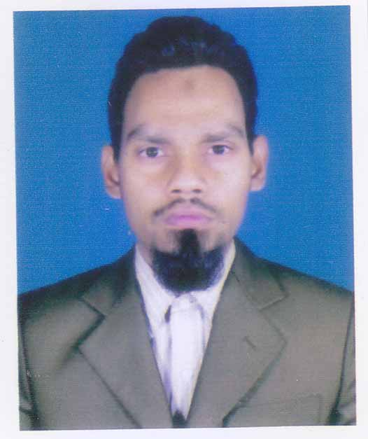

Curriculum Vitae (CV) For Proposed Professional Staff

1. Proposed Position Data Management Expert

2. Name of Firm CSMR Limited

3. Name of Expert Md. Asaduzzaman

4. Date of Birth: 18 August, 1978 Citizenship: Bangladeshi

5. Education
Degree | Date Conferred | Institutions | Division/Class Obtained
M.Sc. in Statistics | 2002 | Rajshahi University, Rajshahi | 2nd Class
B.Sc. Honours in Statistics | 2001 | Rajshahi University, Rajshahi | 2nd Class

6. Areas of Expertise:
Database Development, Database administration, Data management, Data cleaning, FoxPro, CSPro, SQL, SPSS, Relational databases, Database marketing, Data warehousing systems, Data analysis.

Personal Summary
A bright, talented and self-motivated data analyst who has excellent organisational skills, is highly efficient and has a good eye for detail. Has extensive experience of assisting in the development and upgrading of database systems and analytical techniques. Able to play a key role in analysing problems and come up with creative solutions as well as producing methodologies and files for effective data management. A quick learner who can absorb new ideas and can communicate clearly and effectively.

Personal Skills
Analytical, People skills, Evaluating

Duties:
- Manipulating, cleansing & processing data using FoxPro, CSPro, Excel, Access and SQL.
- Responsible for loading, extracting and validation of client data.
- Liaising with end-users and 3rd party suppliers.
- Analysing raw data, drawing conclusions & developing recommendations.
- Writing T-SQL scripts to manipulate data for data loads and extracts.
- Developing data analytical databases from complex financial source data.
- Performing daily system checks.
- Data entry, data auditing, creating data reports & monitoring all data for accuracy.
- Designing, developing and implementing new functionality.
- Monitoring the automated loading processes.
- Advising on the suitability of methodologies and suggesting improvements.
- Carrying out specified data processing and statistical techniques.
- Supplying qualitative and quantitative data to colleagues & clients.
- Using Informatica & SPSS to extract, transform & load source data from transaction systems.
Key Skills and Competencies:
- Attention to detail & ability to work in a pressurised time sensitive environment.
- Experience running complex and high volume ETL processes.
- Exposure to MIS/data warehouse applications.
- Checking of supplied data for sense, consistency and accuracy.
- Sound understanding of relational, object and dimensional databases.
- Extensive experience with CSPro, SQL/Server T-SQL, DTS/SSIS & Excel 2003/2007/2013.

7. Countries of Work Experience: Bangladesh

8. Languages
 | Speaking | Reading | Writing
Bangla | Excellent | excellent | excellent
English | Excellent | excellent | excellent

9. Employment Record

From 2015 To Till date
Data Analysis at CSMR(Center for Social and Market Research), Adabar, Dhaka

From 2012 To 2014
Executive of Data Analysis at IRC (Innovative Research & Consultancy) Limited, Banani, Dhaka

From 2007 To 2012
Senior Executive of Data Analysis for Five years at The Nielsen Company Bangladesh Limited, Dhanmondi, Dhaka

From 2005 To 2007
Computer Programmer for Two year at Omeca Coaching Limited, Farmgate, Dhaka-1205

From 2002 To 2005

Executive of Data Analysis for Two year at Somra-MBL Company Limited, Lalmatia, Dhaka

10. Detailed Tasks Assigned | 11. Work Undertaken that Best Illustrates Capability to Handle the Tasks Assigned
Overall monitoring and evaluation of the project performance. The specific tasks are:  - Prepare M&E strategy and plan and implement surveys;  - Define and identify City and municipal Partnership Agreement Areas (PAAs) including development of detailed maps of each area in consultation with PMU, CCs/municipalities, and other relevant organizations;  - Determine the indicators of health situation and health care services of the urban poor;  - Designing survey methodology and sampling techniques for household, health facility and periodic monitoring surveys;  - Design instruments for both qualitative and quantitative surveys;  - Coordinate qualitative survey using PRA approach;  - Training to the field staff; monitoring and supervision of field work;  - Designing data entry package;  - Data management and analysis;  - Staff management;  - Linkage with different government, NGO and donor agencies;  - Prepare survey reports;  - Disseminate survey findings;  - Provide feed back about progress and outcome, strength and weakness of the PA NGOs to the stakeholders and assist PAs and other firms in taking necessary decision. | Name of assignment or project: Government of People’s Republic of Bangladesh Expanded Program on Immunization (EPI) Coverage Evaluation Survey, 2016.  Year: November to May 2017  Sample Size: 35000, Area: All over the Bangladesh Client: CSMR Bangladesh  Main project features: Monitoring and Evaluation  Positions held: Data Analyst  Activities performed: Associated in sampling design of in house evaluation, analysis and report writing  Name of assignment or project: Upazila Survey-2016.  Year: 2016  Sample Size: 1600, Area: All over the Bangladesh Client: SRGB Bangladesh  Activities performed: Data Entry and analysis.  Name of assignment or project: RETAIL OUTLET CENSUS-2015 (Unilever).  Year: 2015  Sample Size: 500000, Area: All over the Bangladesh Client: Somra-MBBL Limited  Activities performed: Data Entry and analysis.  Name of assignment or project: Sarbik Gram Unnayan kormochy (CVDP-2 Phase).  Year: November to May 2012  Sample Size: 500000, Area: All over the Bangladesh Client: Government of Bangladesh  Main project features: Monitoring and Evaluation  Positions held: Data Analyst  Activities performed: Associated in sampling design of in house evaluation, analysis and report writing  Name of assignment or project: RETAIL OUTLET CENSUS-2014 (Grameen Phone).  Sample Size: 400000, Area: All over the Bangladesh  Year: 2014  Client: Somra-MBBL Limited  Activities performed: Data Entry and analysis.  Name of assignment or project: Climate Asia Survey Bangladesh.  Sample Size: 1000, Area: All over the Bangladesh  Year: 2013  Client: IRC Limited Bangladesh  Activities performed: Data Entry and analysis.

12. Certification:
I, the undersigned, certify to the best of my knowledge and belief−

(i) this CV correctly describes my qualifications and my experience

(ii) I am not employed by the Executing /Implementing Agency

(iii) I am/am not in regular full-time employment with the Consultant or the Sub-Consultant

I understand that any wilful misstatement described herein may lead to my disqualification or dismissal, if engaged.

_______________________________________________ Date: ______________
Signature of expert or authorized representative of the firm Day/Month/Year

Full name of authorized representative: Md, Asaduzzaman

