RESUME
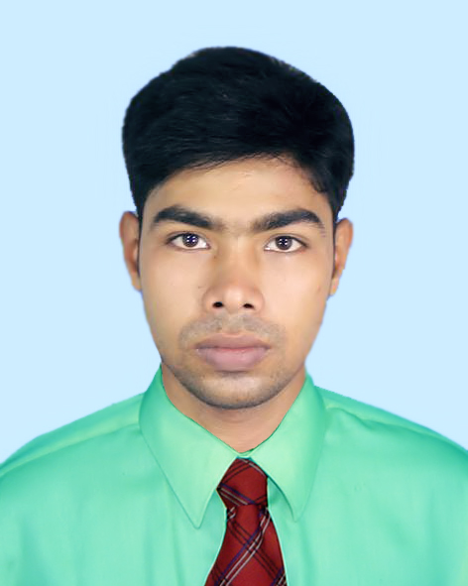
Of
Ashis Chakrabarty
.
Contact: +01316-261588

CARRIER OBJECTIVES:

Ready to work in any challenging environment that offers the opportunity for self-improvement and to prove myself as a professional service holder.

PERSONAL INFORMATION:

Name : Ashis Chakrabarty.
Father’s Name : Anando Chakrabarty .
Mother’s Name : Gayatri Chakrabarty .
Date and Place of Birth : Oct 27, 1995. Jessore, Bangladesh.
Religion : Hindu
Marital Status : Unmarried
Gender : Male
Nationality : Bangladeshi (By Birth)
Contact Address : Ashis Chakrabarty
Sujatpur, Mashiahati,Monirampur, Jessore.

Permanent Address : Ashis Chakrabarty
Vill: Sujatpu
Post: Mashiahati
Thana: Monirumpur,Dist: Jessore
Bangladesh

EDUCATIONAL INFORMATION:

Certificate/ Degree | Passing Year | Name of Institution | Board/ University | Dicipline | Division/CGPA
S.S.C | 2012 | Mashiahati high School | Jessore | Humanities | 3.50
H.S.C | 2014 | Mashiahati Degree College | Jessore | Humanities | 3.70
B.S.S(Honars) | 2019 | Mashiahati Degree College | National University | Political Science | Wating

COMPUTER SKILLS:

- Operating Systems: Windows98, Windows 2000 Professional and Server, Windows XP Professional, Windows 7 Professional
- Application Package: MS Word, Excel, Power Point, Office Application Programming.

EXTRA CURRICULAM:

- Good communication skill over English.
- Leadership quality.
- Attended in various cultural programs..

REFERENCES:

Hiramon Biswas
Assistant Director
Burrueo of nonformal Education
Dc Office
Khulna
Cell:- 01711976462
Mohanondo Biswas
Assistant Professor
Pioneer Girl’s College.
Khulna.
ID-017742
Cell:- +88 01712-132382

I, the undersigned certify that, according to my knowledge and belief, this resume is correctly described by myself and my qualifications. I understand that, any willful misstatement described here, may lead to my disqualification or dismissal, if employed.

Date: 22/07/2019 Signature:
Ashis Chakrabarty

