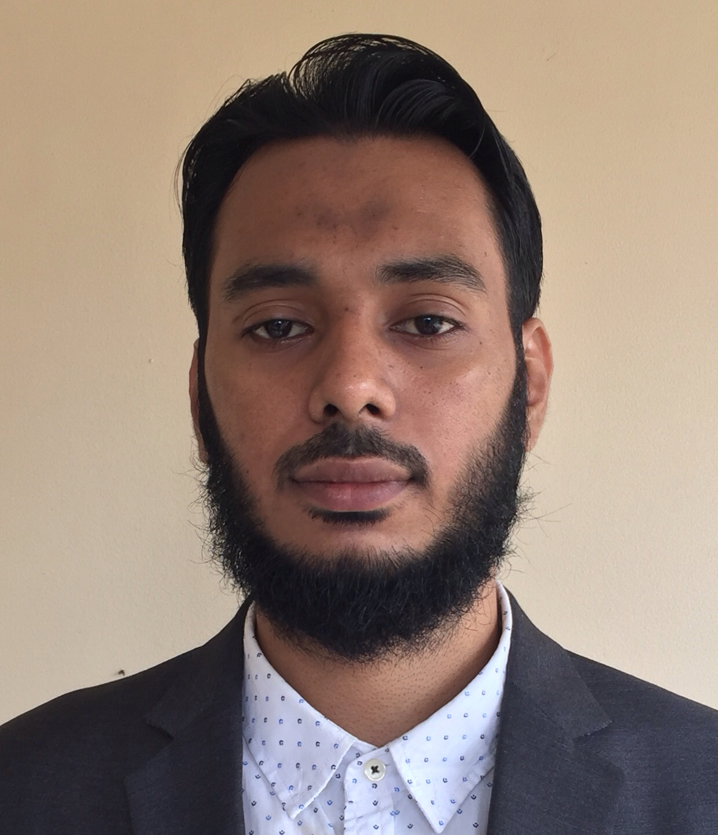

ASIF AHMED
Contact No: 01672197681
Email: Assif_ahmed@live.com

Career Objective:
To increase my knowledge, experience, aptitudes and capacities within a company, in order to grow as a better person and professional as well as take challenges.

Profile:
I am a self motivated person and believe in hard work, integrity, perseverance and dedication towards the work on my hard advancement through explanation to newly acquired knowledge in future.

1. Educational Qualifications:

B.S.C in Computer Science and Engineering  Name of University  Year of Completion  Result | : Sylhet International University  : 2017  : 2.84 Out of 4.00
Higher Secondary Certificate (H.S.C.)  Name of College  Year of Completion  Board  Group  Result  Secondary School Certificate (S.S.C)  Name of School  Year of Completion  Board  Group  Result | :Sylhet Government college, Sylhet  : 2012  : Sylhet.  : Science  : 4.30 Out of 5.00  : Shahjalal jameya Isalmia kamil madrasah, Sylhet  : 2010  : Madrasah  : Science  : 5.00 Out of 5.00

2. Language Proficiency:
Language | Speaking | Writing | Reading | Listening
English | Very good | Very good | Average | Average
Bangla |  | native

Communication: Very good verbal and written communication competence both in Bangla and English.
3. Interests and Activities:
Traveling, Language, Public relation etc.
4. Computer Skills:

MS OFFICE | PHOTOSHOP | INTERNET | OS | TYPING
SOFTWARE MAINTENANCE |  | DESIGN | PROGRAMMING | DATABASE

Personal Details:

Name  Father’s Name  Mother’s Name  Permanent Address  Present Address  Sex  Date of Birth  Nationality  Religion  Height  Blood Group  Marital Status  NID  Passport  Mobile Number  Email | : Asif Ahmed  : Md. Abdul Kadir  : Dilara Begum  : Ward no: 03, Uttarbazar, Kulaura P.O: Kulaura,  P.S: Kulaura, Dist: Moulovibazar.  : #175/1, Norshingtila, Bagbari, Sylhet - 3100.  : Male  : 30th January 1994  : Bangladeshi by birth  : Muslim  : 5 feets 7 Inches.  : A +ve  : Unmarried  : 19945826503000046  : AG9436187  : +8801672197681  : Assif_ahmed@live.com

Signature:

ASIF AHMED

