Contact
Address:
City: Sylhet, Area: Shibgonj, House No: Sonali 1- 2nd Floor.
Bangladesh

Phone:
+88 01740 465647

Email:
pksakib@gmail.com

Languages
English- Fluent
Bangla- Fluent
Hindi- Midium
Azharul Haque Chowdhury
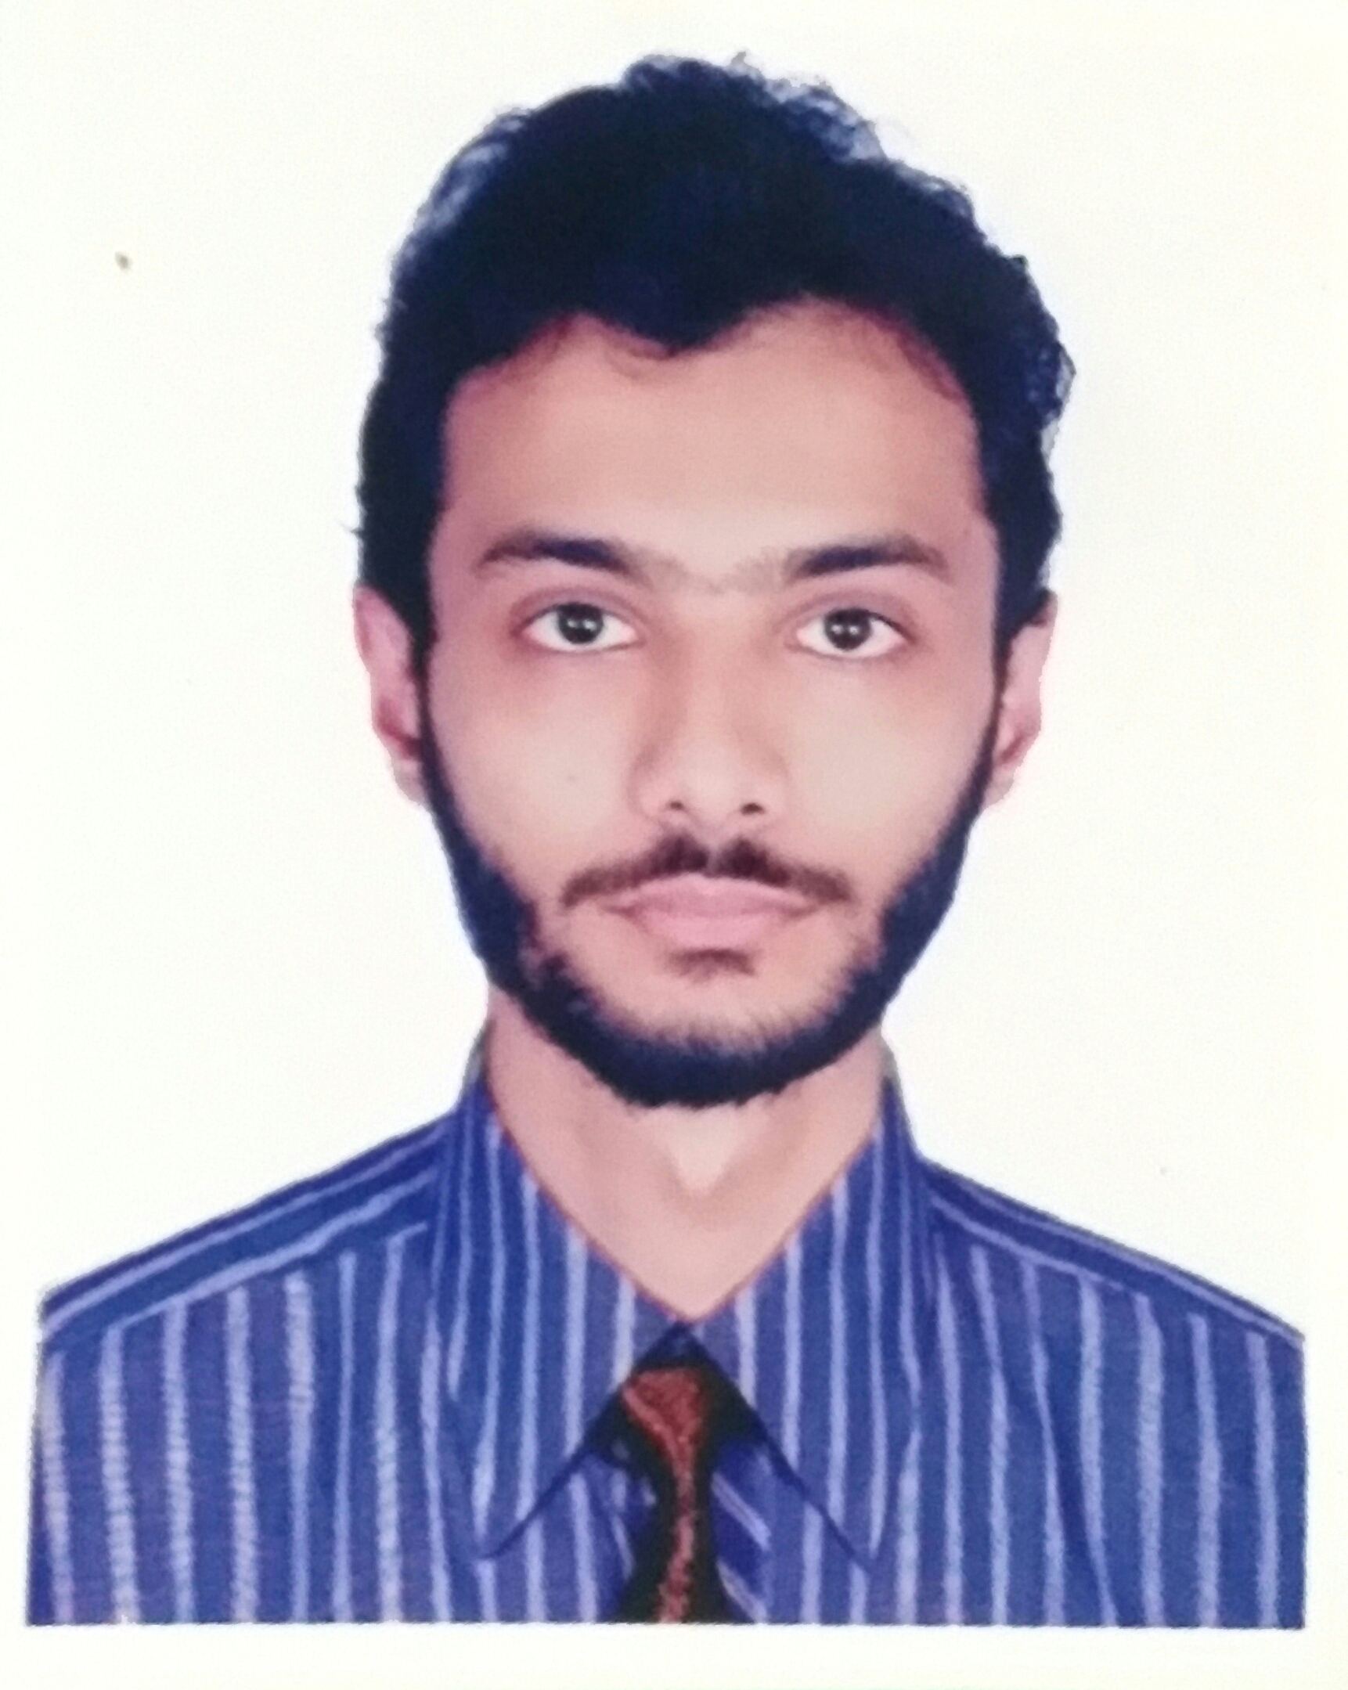

Summary
Web Developer specializing in front end and backend development. Experienced with all stages of the development cycle for dynamic web projects. Experienced with numerous programming languages including HTML5, PHP , CSS, MySQL, Oracle.
I also have knowledge in JavaScript, Ajax and Android.
Strong background in project management and customer relations.

Skill Highlights
- Project management  - Strong decision maker  - Complex problem solver | - Creative design  - Innovative  - Service-focused

Experience
Web Project - Food delivery dynamic website, Dynamic Rent a car website, Student project info dynamic site for university.
Java Project – Java graphics ball game, Class Routine app, Bus schedule app, IQ game, Java networking app, etc.
Android – Apps for Tourist (Not dynamic).

Some of my project link:
Github link- https://github.com/pksakib

Qubee Wimax 4G Modem (ISP) : I worked here 1 year as sales manager – 2012

Education
Bachelor of Science: Computer Science and Engineering - 2019
North East University Bangladesh

HSC- Science: Modan Mohon College - 2013
Sylhet,Bangladesh

SSC - Science: The Aided High School – 2011
Sylhet,Bangladesh

Extra Curriculum Activities

- President of Duronto Social & Cultural Organization.
- Member of Social Service Club (North East University).
- Personally work with blood donation, Relief work for flood suffering people.

