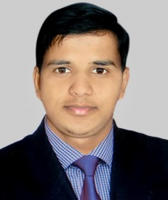
Azizur Rahman Shahin
Village : Labourpara
Post : Papermill-3080
Upzilla : Chhatak
Dist : Sunamgonj
Mobile : +8801774114853

E-mail : ar_shahin@yahoo.com

Career Objective:

Seeking a standard position in an institution, that provides me a challenging opportunity to combine exceptional interpersonal skills & employing my expertise in related fields.

Academic Qualification:

Higher Secondary Certificate (HSC)
Board : Sylhet Board
Institution : Chhatak Hons. College, Sunamgonj.
Group : Humanities
Passing Year : 2017
Grade : 3.42 (Out of 5.00)

Secondary School Certificate (SSC)
Board : Sylhet Board
School : Haji Komor Ali High School
Group : Science
Passing Year : 2015
Grade : 3.78 (Out of 5.00)

Computer Skills:
- Windows operation, MS Office, Internet Operation.
- Short Course Completed On

Language Skills:
- Excellent command on written and verbal communications in English and Bengali.

Experience:
- 1 year working experience as a computer operator.

Personal Information:

1. Name | : Azizur Rahman Shahin
2. Father's Name | : Monir Miah
3. Mother's Name | : Ayesha Begum
4. Permanent Address | : Village : Labourpara  Post : Papermill-3080  Dist. : Sunamgonj
5. Present Address | : Village : Labourpara  Post : Papermill-3080  Dist. : Sunamgonj.
6. Date of Birth | : 03/08/1998
7. Sex | : Male
8. Religion | : Islam
9. Nationality | : Bangladeshi
10.Blood Group | : O+

Interest:

- Challenging Job
- Traveling to natural places
- Musical & Cultural Programs

I hereby, declare myself that all the statements in this resume are authentic, complete and correct to the best of my knowledge and belief.

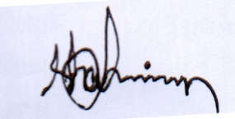

Date: 30.04.2018 (Azizur Rahman Shahin)

