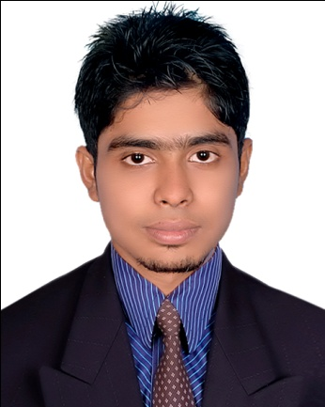
Curriculum Vitae

ROBEL HOSSEN

MAILING ADDRESS

C/O. Majibur Rahman

Vill- Palashpur, Post: Palashpur,

Upazilla- Kapasia, Dist- Gazipur.
Cell: 01551810848, 01928002942

CAREER OBJECTIVE :

Intend to work in a Challenging and competitive environment where strong sense of responsibility and commitment requires; of word provide job satisfaction and the place provide potential avenues for learning and growing.

ACADEMIC ABSTRACT

Diploma-in-Engineering
Institution : Dhaka Polytechnical Institute
Subject : Food Technology
Result : 2.61 (out of 4.00)
Course : 04 (Four) years
Passing Year : 2014

Secondary School Certificate (S.S.C)

Institution : Bhawal Chandpur High School
Board : Dhaka Board
Group : Business Studies
Year of Passing : 2010
Result : GPA 3.94 (out of 5.00)

It Knowledge:

- Operating System : Windows XP, Windows 7,
- MS office : M/s Word, M/s Excel, M/s Power Point, M/s Access.
Have basic knowledge on computer Networking.

Language Proficiency:

** Good Command in Speaking & Written in Bangla.
** Good Command in Speaking & Written in English.

Current Page-2

Experience:

I have been worked as a “Asst. Chemist” at ATN Food & Consumer Product, Tongi, Gazipur for 03 (Three) Month. Now I have work at PRAN-RFL group Department of "Quality Assurance" (QA) under Quality Control as a Supervisor on 17-11-2016 to continue.

Hobbies and Interest :

* I also like traveling. I also have an interest on reading novels and listening music & Crating Website with Joomla.

PERSONAL DETAILS :

Name : Robel Hossen
Father’s Name : Majibur Rahman
Mother’s Name : Aynob Begum
Permanent Address : Vill- Palashpur,
P.O: Polashpur(1730),
P.S: Kapasia, Dist: Gazipur.
Present Address : Vill- Palashpur,
P.O: Polashpur(1730),
P.S: Kapasia, Dist: Gazipur.
Date Of Birth : 30 October, 1994
Sex : Male
Marital Status : Married
Religion : Islam
Nationality : Bangladeshi (by birth)
Height : 5' - 2"

References:

1. Suresh Chandra Mondal 2. Morshed Alam Siddque
Instractor (Camical & Food Technology) Junior Instractor (Camicla & Food Technology)
Dhaka Polytechnic Institute Dhaka Polytechnic Institute
Tajgaon, Dhaka-1208. Tajgaon, Dhaka-1208.
Cell: 01817620985 Cell: 01711106900

Declaration Of Authenticity

I declare hereby that all information’s Presented are true. If requested documents can be supported by authentic certificate/papers.

Robel Hossen

Signature with Date

