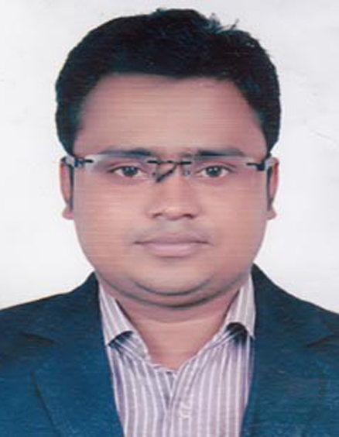
CURRICULUM VITAE
Of
Md. Mufazzal Hossain Babu
Mailing Address:
Vobanipur (Kacharipara)
Sujanagar, Pabna
Mobile No-01751-313600,

E-mail Id: mufazzal.hossain1017@gmail.com

Working Experience
- Suntacruz Denso
- 20/2 Rasulbagh, Muhakhali, Dhaka
- Designation: Technichian & Accounts
- 6 old Gabtoli, Majar Road, Dhaka
- Disle Fuel pump : Tata, Lylel, Hino, Mitchubishi, Etc Other
- Joining Date: 01/04/2014
- Regain Date: 30/06/2018
- Neptune Lefts & Scaleretore
- Motijhil, Dhaka
- Designation: Technichian
- Service & Meatiness - I learned how to do elevator work
- Joining Date: 01/11/2012
- Regain Date: 25/03/2014
- IFAD GROUP
- IFAD AUTO SERVICES LTD.
- Head Office Address: IFAD Tower,Holding No. 07,
- Tejgaon Industrial Area,Dhaka-1208,Bangladesh
- Designation: Executive – Spares
- I've been able to gain gains on various car parts. Especially Ash was able to gain weight on all parts of the Leyland vehicle. And would like to pursue further education in the future.
- Joining Date: 16.05.2019 (Continue)

.

CAREER OBJECTIVES
To work in a challenging environment with a scope of future progress, applying my academic
knowledge and working capacity. I would like to welcome the chance to work as a part of a dynamic working team where I could make a significant contribution while developing my skills yet further.

EDUCATIONAL QUALIFICATION

Diploma in Power Engineer

- Institute : Pabna Polytechnic Institute pabna.
- Group : Power Technology.
- Board : Bangladesh Technical Education Board.
- Passing Year : 2013
- Result : GPA- 3.02 (Out of 4)

Secondary School Certificate (S.S.C)
- Institute : Sujanagar Pilot High School.
- Group : General Electrical Works (SSC Vocational)
- Board : Bangladesh Technical Education Board.
- Passing Year : 2008
- Result : GPA- 3.91 (Out of 5)

PERSONAL INFORMATION

- Name : Md. Mufazzal Hossain Babu
- Father’s Name : Md. Mojammel Hoque Chunnu
- Mother’s Name : Most. Sahanaj Begum
- Present Address : 43 Darusalam, Mirpur, Dhaka
- Permanent Address : Vill-Vobanipur, P.O-Sujanagar
P.S-Sujanagar, Dist-Pabna
- Date of Birth : 21/06/1993
- Nationality : Bangladeshi (By Birth)
- Religion : Islam
- Sex : Male
- Marital Status : Married
- Height : 5′-5″
- Weight : 63 KG
- Blood Group : AB⁺(ve)
- National ID No. : 19937628303000017

Communication skill

- English : Fluent in writing & speaking
- Bangla : Mother language

Computer Skill

- Computer Office Course. Ms- Word, Ms- Excel, Ms- Access, Power Point & Internet.

Reference:
1. Md Kamruzzaman
Manegment Trainee (HR & Admin)
City Group
Mob 01748101514

Declaration

I hereby declare that the above particulars are true to the best my knowledge and belief and I am strong in body and mind, hard working and ambitions to be successful in life. I capable to adjust of all people at any circumstance and have a great interest for team work.

Signature

Md. Mufazzal Hossain Babu

