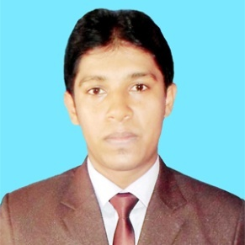
MD. ABAY JAM JAM BADSHA ALOMGIR

alomgir097@gmail.com
H#769, R#23, Block-F
Mobile: +8801744727483 Bashundhara R/A, Dhaka-1212

PERSONAL STATEMENT

To obtain an entry-level position as an Electrical and Electronics Engineers with ABC Technologies, allowing me to utilize my education and internship experience while gaining valuable work experience in a team oriented environment.

Career Profile

- Good understanding of Electrical Drawings, Planning of Projects, Erection & Maintenance.
- Both practical as well as theoretical knowledge of Different Electrical Instruments.

Technical Qualities

Electrical Projects & Maintenance
- Good understanding of Electrical Drawings, Planning of Projects, Erection & Maintenance.
- Both practical as well as theoretical knowledge of Different Electrical Instruments.
- Working more efficiently and productively so that maximum output comes

Strategic Planning
- Regular analyzing of organizations Electrical Load Consumption with Ratios and analysis.
- Planning & scheduling assignments to achieve pre-set goals within time parameters. Formulating long term/short term strategic plans to enhance operations.

Computer Proficiency

- Well versed in Windows 7, Windows Server and Windows 10.
- Proficiency in entire MS-Office, MS-Excel, MS- Power Point.
- Matlab.
- Good understanding of Internet tools.

Personal Qualities

- Excellent Communication, listening and motivating skills.
- Ability to learn quickly is my forte that has helped me successfully manage various jobs given.
- Ability to work with a team of dedicated professionals for achieving the deadlines for the execution.

Badsha Alomgir . Page-2 alomgir097@gmail.com

Education

Bachelor of Science in Electrical and Electronics & Engineering
University: Varendra University, Rajshahi. Year of passing: 2017
Result : CGPA 2.97 (Out of 4)

Higher Secondary School Certificate-(H.S.C)
Institution: Pangu Shishu Niketon Samannita Aboitonik College. Group: Science
Year of passing: 2012. Result:GPA 3.80 (Out of 5)

Secondary School Certificate-(S.S.C)
Institution: Dhokrakul High School. Group : Science
Year of passing: 2010. Result: GPA 4.31 (Out of 5)

Personal Information

Name : Md. Abay Jam Jam Badsha Alomgir
Father's Name : Md. Anisur Rahman
Mother's Name : Mst. Forida Begum
Village : Basupara
Post : Dhokrakul -6260
District : Rajshahi
Date of Birth : 11 December 1994
Marital Status : Unmarried

Reference

Md. Mostafizur Rahman
Sr. System Analyst Independent University, Bangladesh
Mobile: +8801719165941. Email: mostafiz57@gmail.com

